Evidence Gathering for Core Competencies Goals - MyBlueprint instructions (week of April 8 - 12 ) Give time for students to put their three competency goals on my blueprint.
Steps:
- Go to myBlueprint (http://myBlueprint.ca)
- Click Login (Remind them to access their district account when logging in)
- Click School account login
- Enter Surrey to get to sd36 Surrey
- Click Surrey account login
- Enter surrey schools user name Click next
- Enter surrey schools password Click sign in
- You will be on your dashboard. Click Goals. Review Goals from November.
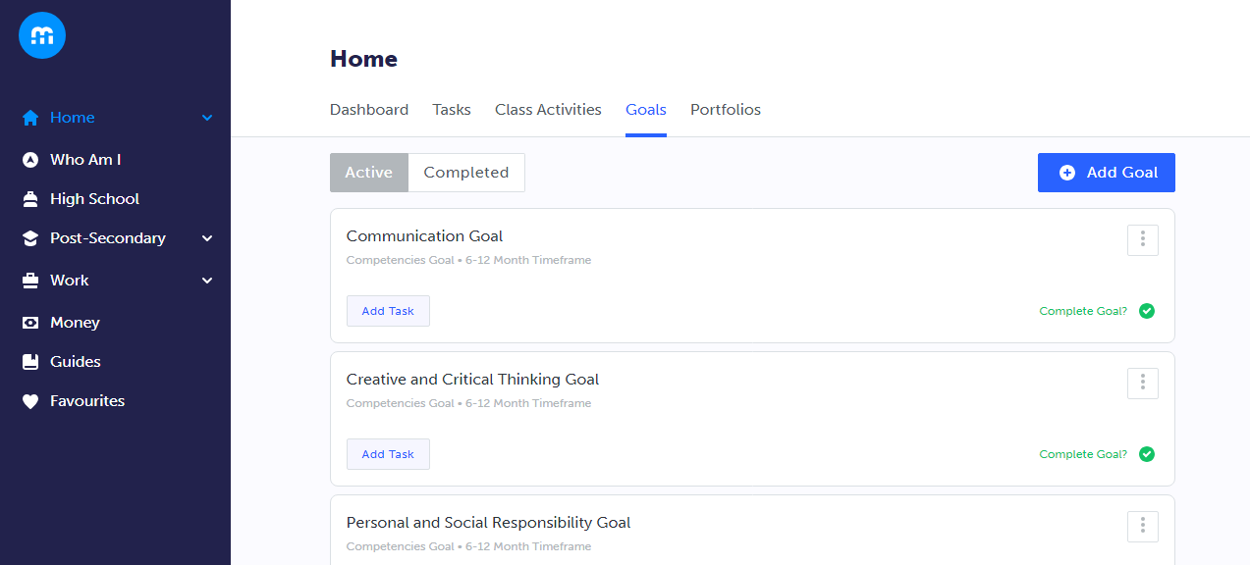
- Click Portfolio
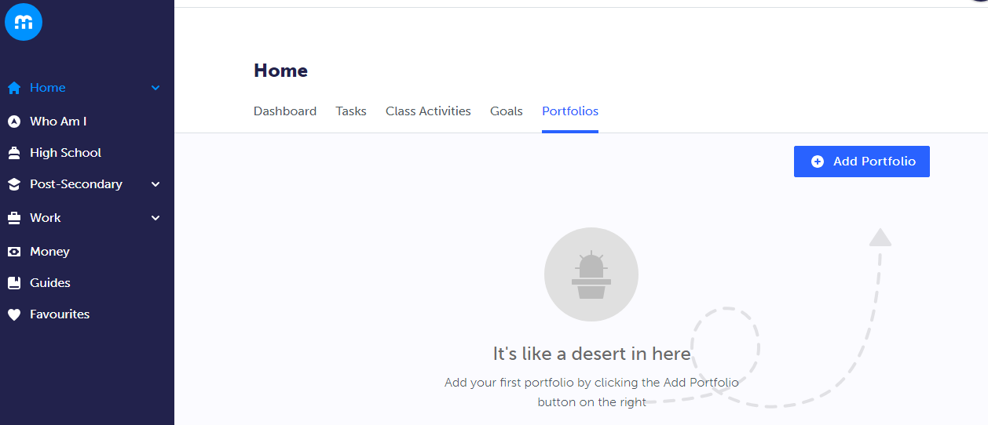
- Click Add Portfolio
- Title the Portfolio : Evidence for Core Competencies. Click Add Portfolio.
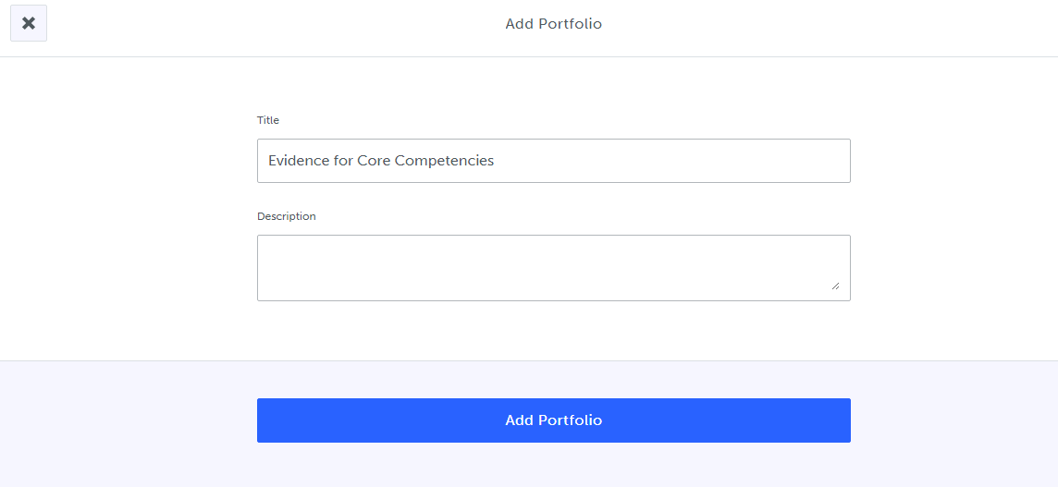
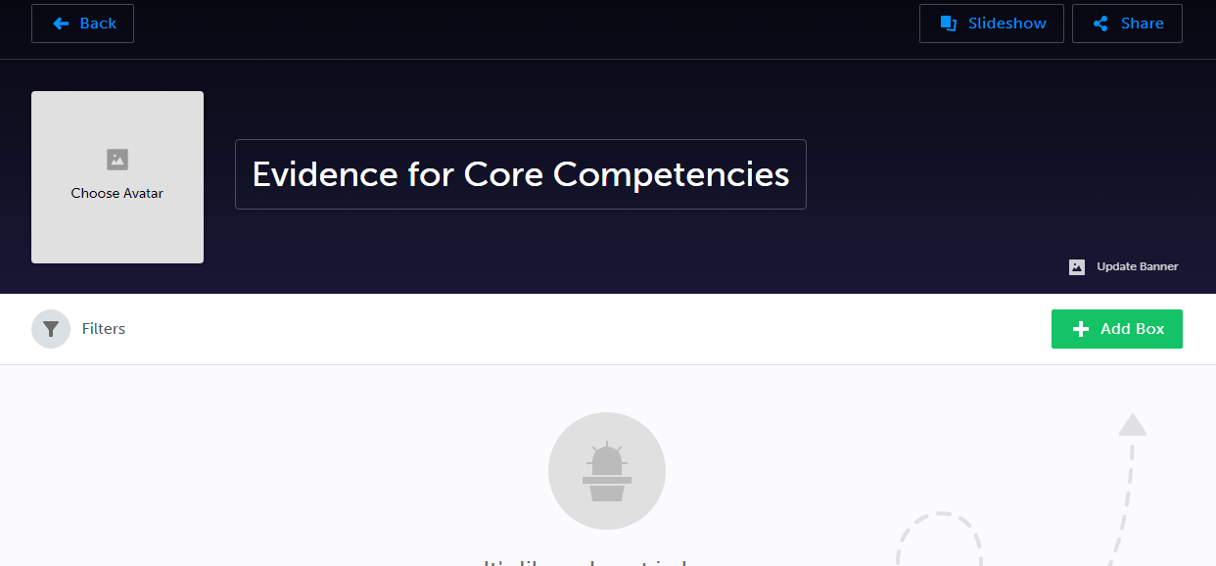
- Before we add an evidence box, copy first goal. Click Back. Click Goals.
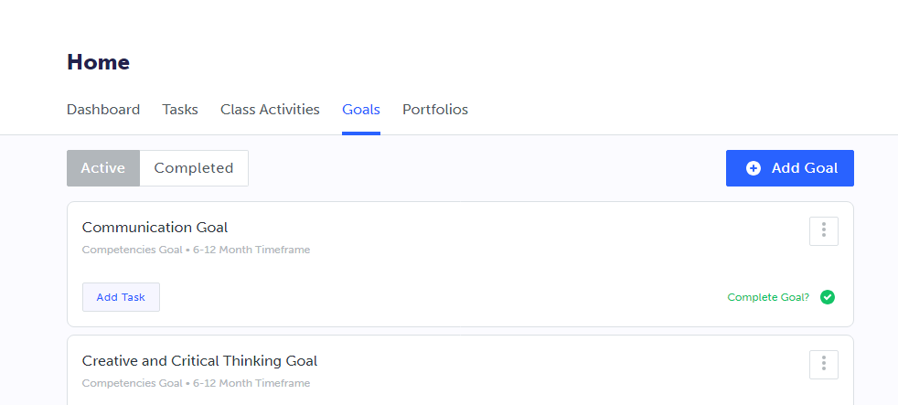
- Highlight and Copy Goal.
- Click Portfolio
- Click Evidence for Core Competencies
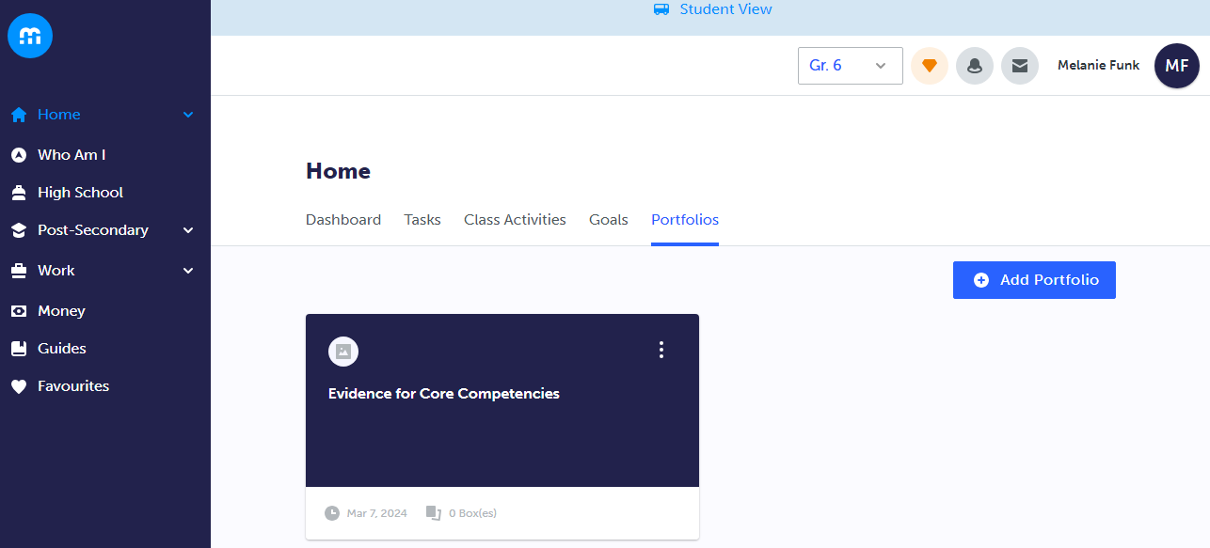
- Click Add Box
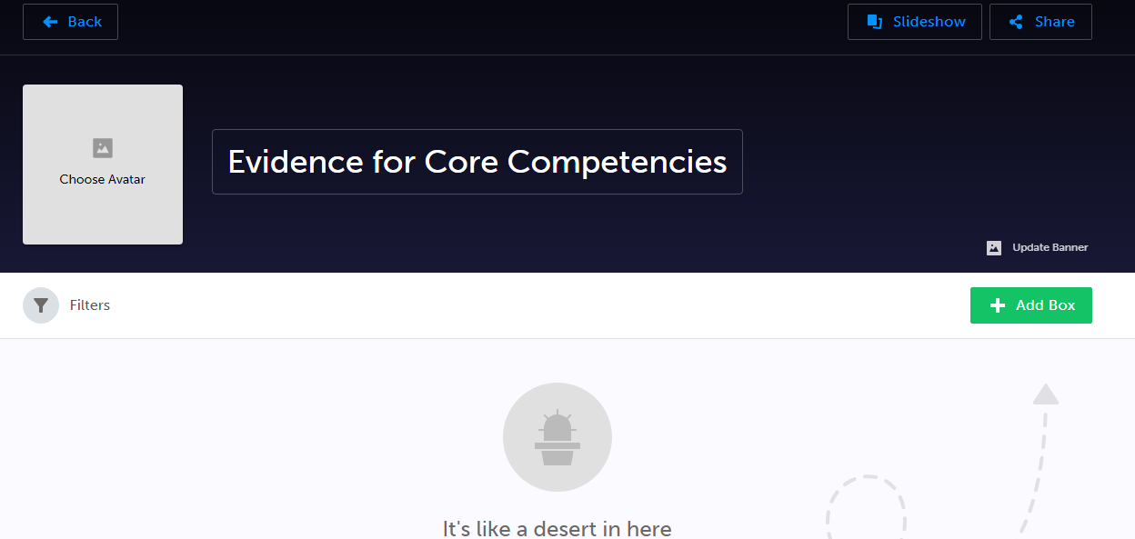
- Click Add Journal
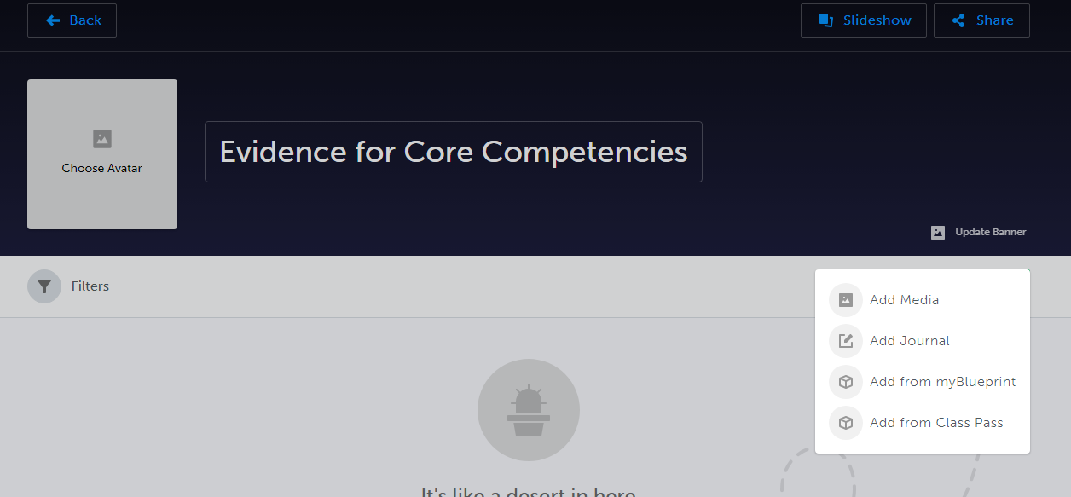
- Paste first Goal
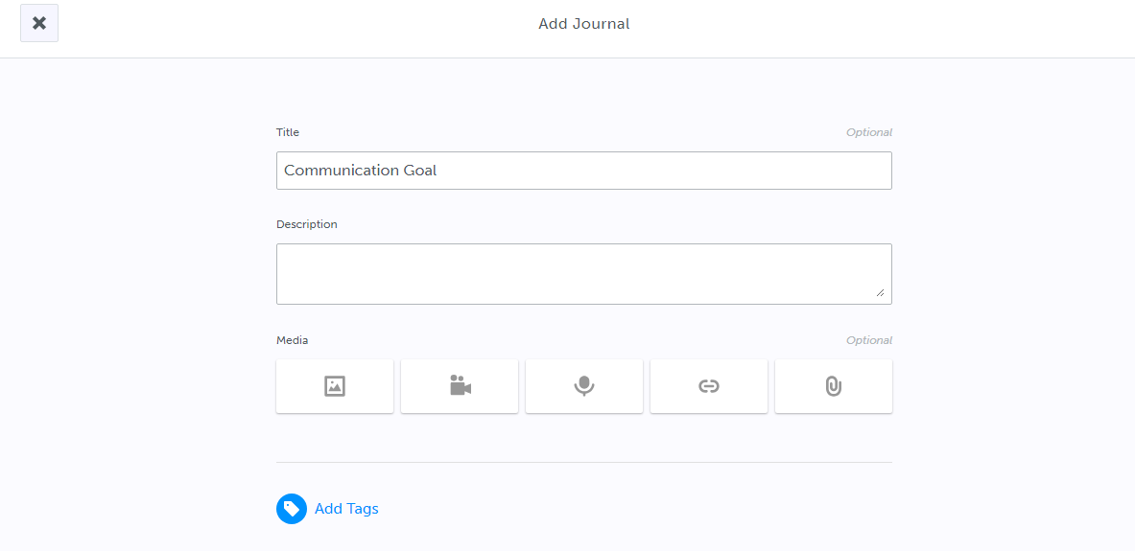
- Add evidence – there are 3 ways to add
  - Write in the description box.
  - Insert a photo. Click media icon. If using a phone take photo of evidence.
  - Attach a file/link/image.
    - If using a phone, Click attach button. Go into google drive. Add file.
    - If using a laptop. Click attach button. Click on files to upload. Click file you want to select. Click Upload.
(You are also able to drag photos and files as well)
- Click Post
- Repeat steps 12-20 for your other two goals.
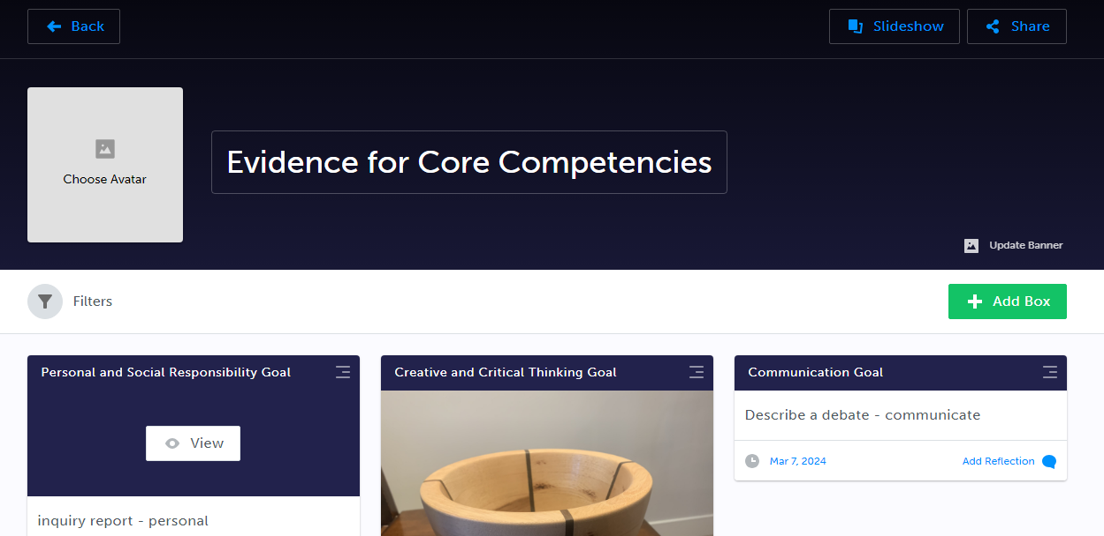
- You have completed the task when you have evidence for three goals entered on my blueprint.
(There is an instructional video provided if needed)
Recording-20240307_124139.webm
MY BLUEPRINT LOGIN INFORMATION
https://surreyschoolsone.ca/resources/my-blueprint - ACCESS STEPS
Information:
There will be a comment on MyEd report card that lets parent/guardians know that they can look at their child’s competency goals and evidence on myBlueprint.

