North Ridge Teddy Bear Toss

Help The Vancouver Giants help Kids!

Bring a new or gently used stuffed animal and help build our…

North Ridge Teddy Bear Mountain
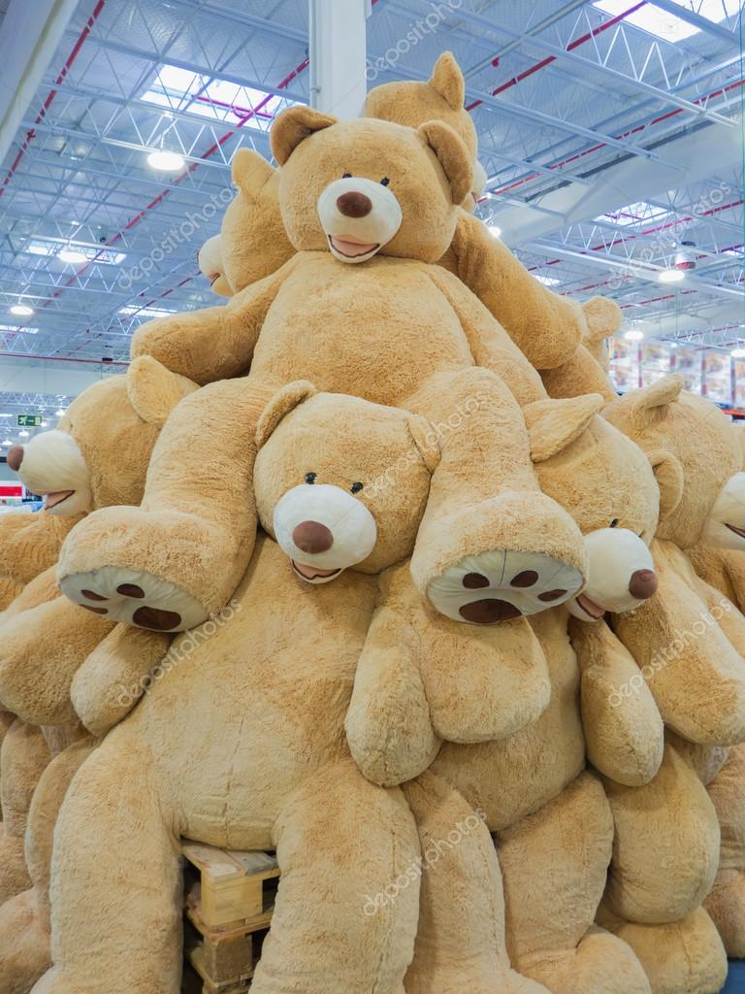
Students donating a stuffed animal will be entered into a draw for a Vancouver Giants Prize Pack, a Canucks Prize Pack or a Surrey Eagles game worn Jersey!

Collection will be from Monday, November 25th to Tuesday, December 3rd

