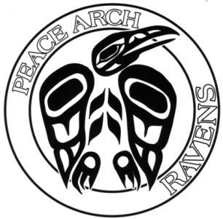
15877 Roper Avenue
White Rock, BC V4B 2H5 Phone: 604-536-8711
Fax: 604-536-8732
École Élémentaire
Peace Arch
Elementary School

Dear Parents/Guardians,
As you know, the Ministry of Education has been shipping rapid tests to schools for distribution to students. Our school has not yet received our shipment.
Last Thursday, Health Canada sent out an advisory about potential risks associated with the misuse or accidental ingestion or spillage of COVID-19 rapid antigen test kit solutions. Health Canada has determined that the kits are safe and effective when used as intended. However, many test kits include liquid solutions with chemical preservatives, such as sodium azide and Proclin that may be poisonous if swallowed or absorbed through the skin, particularly in children and pets.
As a result of this advisory, we will not be sending test kits home with students but will instead require parents/guardians to pick them up at the school. Once our school has received our shipment, we will be communicating more detailed pick-up instructions with you.
Once you have received your test kits, please store these kits out of the reach of children and pets. The BCCDC’s website has more information on the test kits and safety.
If you have any questions about the distribution process, please contact the school.
Thank you for your continued support.
Sincerely,

Ms. Laureen Boulet
Principal

