FLEETWOOD PARK SECONDARY SCHOOL

Online locker selection information 2019-2020

Fleetwood Park Secondary uses an online locker selection process. Students are not assigned a locker in homeroom, but instead, can go online and select their own locker.

To choose your locker, log into the following website:

http://fleetwood.lockerassignment.com

Selecting a locker is easy. Log into the system by entering your STUDENT NUMBER, and your birthday as your password. The format of your birthday is YYYYMMDD. Your student number can be found on previous report cards or online on MyEducation BC. If you still need help with this, please contact the school.

Once you are in, select a floor and area of the school you want to have your locker. You may want to pick an area of the school where you have a majority of classes.

If you are new to Fleetwood Park, or are having trouble logging into the system, the system might not have your log-in information or your correct STUDENT # / birth date. If you have tried logging into the system but cannot, please contact the school so that we can update your information and get you logged in. It takes several days for the website to be updated, so patience is necessary!

Please contact the office if you have any problems with logging in.

Dates / times that students in each grade can start to access the system for 2019/2020
REVISED SYSTEM ACCESSIBILITY:
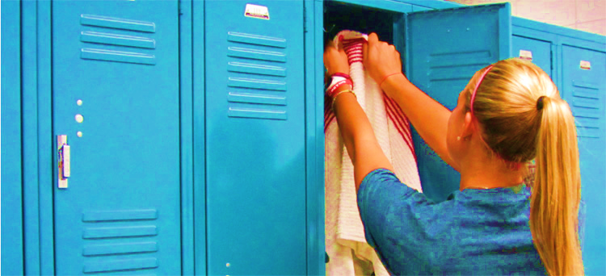
Grade 12: Monday, August 19 @ 10:00 am
Grade 11: Tuesday, August 20 @ 10:00 am
Grade 10: Wednesday, August 21 @ 10:00 am
Grade 09: Thursday, August 22 @ 10:00 am
Grade 08: Friday, August 23 @ 10:00 am

**Note: Once you have selected a locker, the program provides you with a combination. It is yours for the entire year. Please make a note of it. You cannot change your locker or combination. If you forget your combo, log back in at any time for a reminder.

PLEASE REMEMBER:

Students are responsible for the locker which is assigned to them and it is not to be used by any other person.
Only approved locks may be used on student lockers and the combination is registered with the office.
The locker is to be kept clean and food removed on a regular basis.

No illegal substances, weapons or other prohibited or offensive material may be placed in school lockers.

School officials and / or designates may search student lockers at any time and without prior notice in order to ensure compliance with the conditions of use and other school policies and rules. Searches by school officials may include the use of dog units to detect the presence of narcotics or other prohibited materials.

**Please see the Student Agenda online for complete information regarding Locker Conditions of Use.
Revised August 19, 2019

