

June 2025

Dear PAC,

We’ve been working with teachers, staff, and students to promote smart energy conservation behaviours in our schools through campaigns like our holiday shutdown events “***Turn it Off, Before you Take Off”***. Our aim is to turn off or unplug equipment that isn’t in use over school breaks to reduce energy waste from stand-by power.

*Stand-by power, or phantom power, is energy that is drawn to power clocks, lights, or internal memory in electronics/appliances even when they aren’t in use. With all the electronics in classrooms these days, this can really add up.*

This summer, we’re taking the opportunity to unplug large appliances like fridges and freezers. We’re asking for your participation by cleaning out and unplugging the PAC fridge for our summer shutdown.

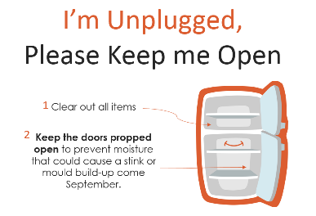If the PAC fridge will not be in use, please:

1. Clean out, unplug, and **prop the doors open** to prevent mildew build up over the summer.
2. Ensure the door is unlocked.
3. Place a notice (see right) to signal this to our custodial staff. This will help them during their summer deep cleaning.

We thank you in advance for helping us meet our energy and sustainability goals.

If you have any questions, please do not hesitate to contact me or our Energy Manager at sustainability@surreyschools.ca

Thank you!