**Creative Writing & Composition 10 Course Description**

**Ms. J. Panas | L.A. Matheson Secondary**

**Objectives & Content**

|  |
| --- |
| Creative Writing (2 credits) provides students opportunities to build their writing skills through the exploration of identity, memory, and story in a range of genres. Composition 10 (2 credits) is designed to support students in their development of written communication through a critical process of questioning, exploring, and sampling. We will engage with content through a variety of activities, such as:   * analyzing (interpreting and evaluating) a range of texts * developing voice in writing * exploring diverse genres, styles and perspectives * experimenting with language and forms * investigating topics of interest/passion * reflecting upon personal and cultural identities * practicing the writing process * developing a portfolio of writing * Reading Workshop, a semester-long unit that takes place every Tuesday after lunch |
| **Big Ideas (deep understandings) for both courses combined:**  1. The exploration of text and story deepens our understanding of diverse, complex ideas about identity, others, and the world.  2. Texts are socially, culturally, geographically, and historically constructed.  3. Language shapes ideas and influences others.  4. Creative writers take risks and persevere.  5. Creative writers are observant of the world.  6. Engagement with writing processes can support creativity and enhance clarity of expression. |

**Supplies Required**

1 three-ring binder

Loose-leaf paper

Blue or black pens

A journal

(*Recommended: highlighters and a planner)

**Attendance**

Attendance is vital to success. Students are expected to attend regularly and on time, and to contribute positively to the classroom environment.

**Late Assignments**

All work should be completed by the due date. Use your class time wisely. Please see me if you have reason to believe that an assignment will be late. While you will not lose marks for late work, consequences may include: completing work in my classroom at lunch or after school;

contacting parents and/or your counselor, especially for frequent or very late work; not being allowed to re-do work; no feedback on your finished work. You cannot hand in an assignment after I return it to the class. However, you may write a similar substitute assignment in the classroom under my supervision.

**Plagiarism/Academic Dishonesty**

Plagiarism means copying without giving credit, regardless of source; this can include tutors or family. Plagiarized assignments may result in consequences including failure, office referral, and meetings with parents. Please see me or the librarian for help if you are unsure how to give credit in your work.

**Assessment**

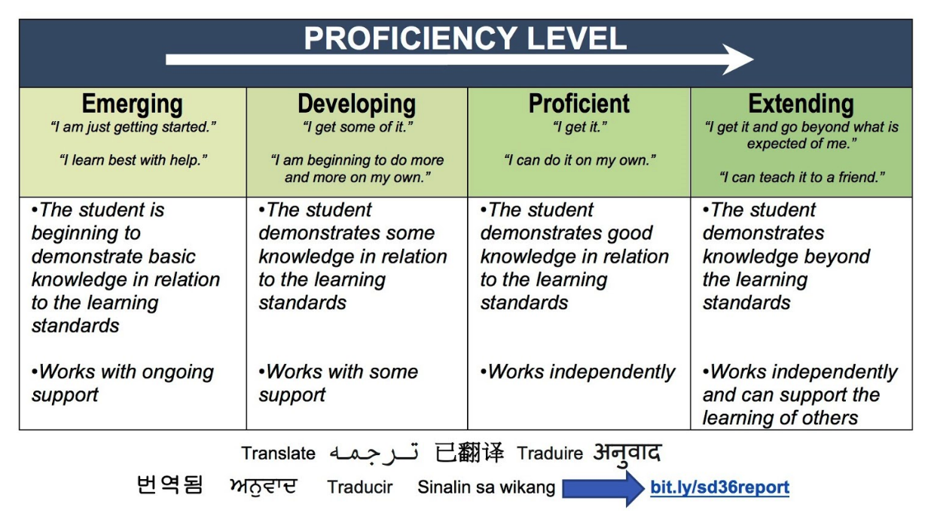Overall assessment for this course will be based on my observations/notes and a portfolio of assignments/rubrics. Some assessment rubrics will be built with student input, and all will use the Ministry of Education Proficiency Levels as shown below. While you will often get feedback (formative assessment), there will not be many summative assessments, so it’s important that you do your best on each one.

**Communication**

Please review this course description with your parent(s)/guardian(s) and have them sign below. Return the whole document to me by **Friday, October 4**; I will return it to you for your records.

Student name: __________________________________________ Class: _________________

Parent/guardian name: __________________________________________________________

Please print clearly

Parent/guardian signature: _______________________________________________________

If there are any comments or questions, please email me at [panas_j@surreyschools.ca](mailto:panas_j@surreyschools.ca). I will usually respond within 2 work days.