**English Studies & Career Life Connections 12 Course Description**

**Ms. J. Panas | L.A. Matheson Secondary**

**Objectives & Content**

|  |
| --- |
| This course combines Career Life Connections and English Studies 12. Students will learn about their career path and develop their final Capstone Project, in which they will demonstrate a variety of English skills (e.g., speaking, representing, writing, and a variety of media). The English curriculum will be used to enhance and support the skills needed for CLC (e.g., listening and speaking skills will improve communications in post-secondary and/or the workplace). We will engage with content for both courses through a variety of activities, such as:   * analyzing (interpreting and evaluating) a range of texts * developing voice in writing and experimenting with language and forms * exploring diverse genres, styles and perspectives in literature * investigating topics of interest/passion * reflecting upon personal and cultural identities, and connecting with the community * researching information for post-secondary life, including education and finances * Reading Workshop, a semester-long unit that takes place every Wednesday * Well-Being, a semester-long unit that takes place every Thursday |
| **Big Ideas (deep understandings) for both courses:**  English Studies 12:  1. The exploration of text and story deepens our understanding of diverse, complex ideas about identity, others, and the world.  2. People understand text differently depending on their worldviews and perspectives.  3. Texts are socially, culturally, geographically, and historically constructed.  4. Language shapes ideas and influences others.  5. Questioning what we hear, read, and view contributes to our ability to be educated and engaged citizens.  6. The examination of First Peoples cultures and lived experiences through text builds understanding of Canadians’ responsibilities in relation to Reconciliation.  Career Life Connections:  1. Career-life development includes ongoing cycles of exploring, planning, reflecting, adapting, and deciding.  2. Career-life decisions influence and are influenced by internal and external factors, including local and global trends.  3. Engaging in networks and reciprocal relationships can guide and broaden career-life awareness and options.  4. A sense of purpose and career-life balance support well-being.  5. Lifelong learning and active citizenship foster career-life opportunities for people and communities. |

**Attendance**

Attendance is vital to success. Students are expected to attend regularly and on time, and to contribute positively to the classroom environment.

**Late Assignments**

All work should be completed by the due date. Use your class time wisely. Please see me if you have reason to believe that an assignment will be late. While you will not lose marks for late work, consequences may include: completing work in my classroom at lunch or after school;

contacting parents and/or your counselor, especially for frequent or very late work; not being allowed to re-do work; no feedback on your finished work. You cannot hand in an assignment after I return it to the class. However, you may write a similar substitute assignment in the classroom under my supervision.

**Plagiarism/Academic Dishonesty**

Plagiarism means copying without giving credit, regardless of source; this can include tutors or family. Plagiarized assignments may result in consequences including failure, office referral, and meetings with parents. Please see me or the librarian for help if you are unsure how to give credit in your work.

**Assessment**

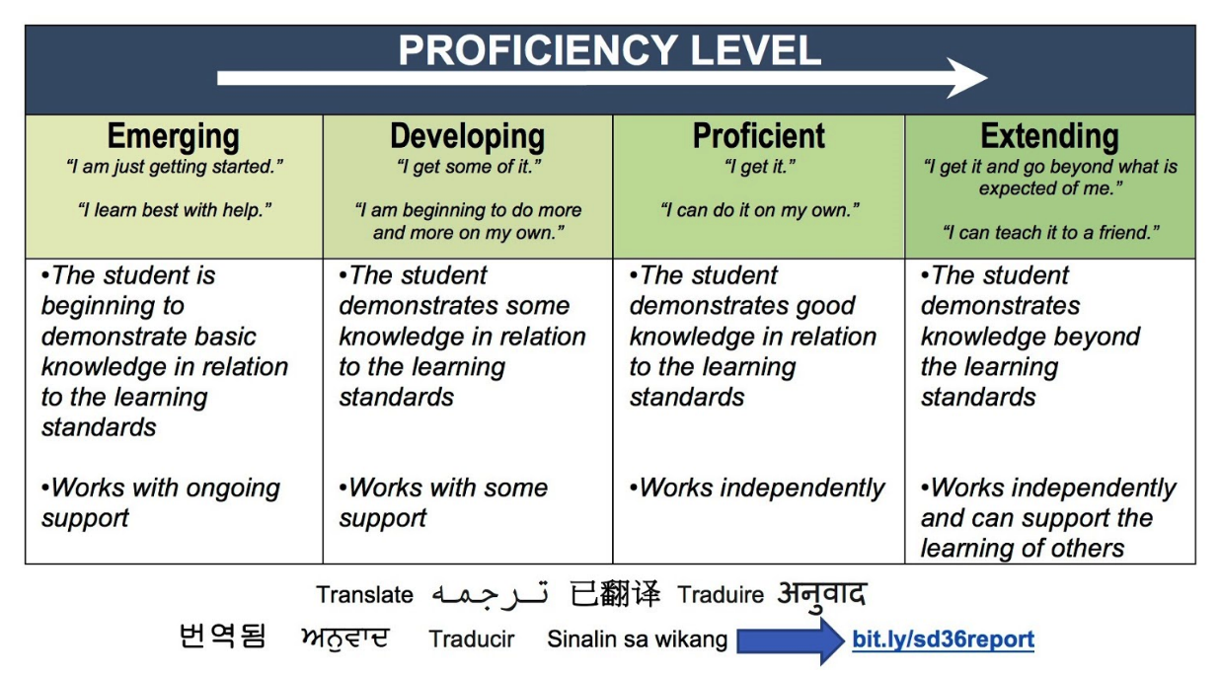Overall assessment for this course will be based on my observations/notes and a portfolio of assignments/rubrics. Some assessment rubrics will be built with student input, and most will use the Ministry of Education Proficiency Levels as shown below. While you will often get feedback (formative assessment), there will not be many summative assessments, so it’s important that you do your best on each one. **Please note that the Capstone assessment is REQUIRED for graduation**.

**Communication**

Please review this course description with your parent(s)/guardian(s) and have them sign below. Return the whole document to me by **Friday, October 4**; I will return it to you for your records.

Student name: __________________________________________ Class: _________________

Parent/guardian name: __________________________________________________________

Please print clearly

Parent/guardian signature: _______________________________________________________

If there are any comments or questions, please email me at [panas_j@surreyschools.ca](mailto:panas_j@surreyschools.ca). I will usually respond within 2 work days.