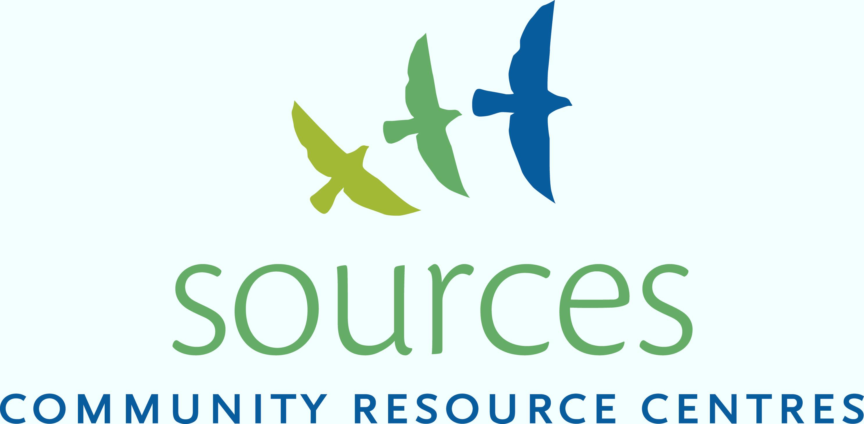

Parent/Teen Turning Points



**FREE** Group for Parents/Caregivers of Teens Involved With Substances

Tuesdays beginning February 21st 5:30-7:00 pm

Location: Earl Marriott Secondary School – Library

Dates: February 21, 28, March 7, 28, April 4, 11 & 18

A safe, confidential space for caregivers to come together to share, explore and learn about:

* Understanding Substance Use
* Adolescent Development
* Communication
* Boundaries
* Crisis Management
* Resilience – its importance and how it develops
* Self-Care
* Youth/Adult Connection

**Register:** 604-538-2522 or [suservices@sourcesbc.ca](mailto:suservices@sourcesbc.ca)

Each participant will receive a “Recognizing Resilience” Workbook