Parents Night Out
Only 2 Weeks Away!

Our Parents Night Out / Pub Night Playground Fundraiser is less than 2 weeks away! We still have a limited number of tickets available so get yours before it is too late.

We have some awesome square board prizes up for grabs such as a Night for two at the Sheraton Four Points with continental breakfast, Boston Pizza Gift Card, two movie passes and bottle of wine. And we have a VIP package for four to the Royal Canadian Circus.

We will have a silent auction and 50/50 draw so please bring some cash. We have a Canucks basket with Jacket, Booze Basket, Epicure Basket, Pet Basket, Spa Basket and many more!

We have two ticket pickup/purchase times coming up this week and next. They are:

Wednesday April 17th from 7pm to 8pm - Subway (108 and 148)
Thursday April 25th After School in the PAC Room

If you are unable to make our purchase times please email us at Riverdale.PAC@hotmail.com and we will make arrangements to get you your tickets. We accept e-transfer.

When: Saturday April 27th, 5 - 8pm
Where: The Taphouse Guildford, 15330 102a Ave, Surrey
What: Burger (Chicken, Beef or Veggie), Fries or a Salad and a Drink (Beer, Wine or a High Ball)

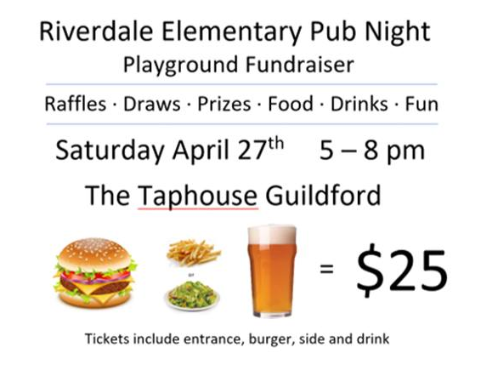

Please share our event page with friends and family so they can join us for a fun night and help support our fundraiser! https://www.facebook.com/events/598573957256377/

Thank you!

