Parents Night Out
This Saturday!

Our Parents Night Out / Pub Night Playground Fundraiser is taking place on Saturday! We still have a limited number of tickets available so get yours before it is too late.

Our last ticket pickup date is after school this Thursday in the PAC room. Come by with cash or cheque (payable to Riverdale PAC) to get your tickets.

You can also pre-order your tickets by sending an e-transfer to Riverdale.PAC@hotmail.com and we will set aside tickets for you to pick up on Thursday. If you can’t make the pick up please email us to make other arrangements.

Fraser Heights Blackbelt Academy has donated a birthday party package for 20 kids, two months of free classes, uniform and other items worth over $650. We have Lions tickets, Canucks Jacket and other Canucks swag, Passion Party and many more awesome baskets up for auction.

We will have the silent auction, square board and 50/50 draw so please bring some cash. There is an ATM there but we recommend bring cash with you to save the ATM fees. We will accept credit cards for the silent auction.

When: Saturday April 27th, 5 - 8pm
Where: The Taphouse Guildford, 15330 102a Ave, Surrey
What: Burger (Chicken, Beef or Veggie), Fries or a Salad and a Drink (Beer, Wine or a High Ball)

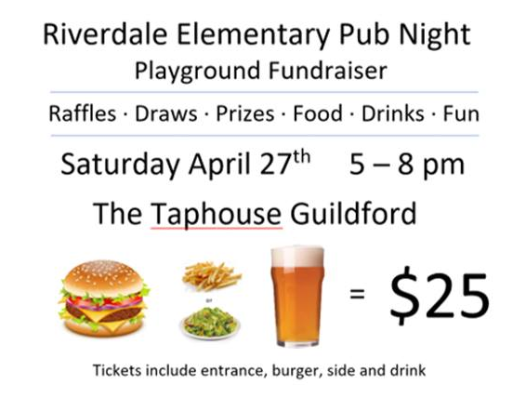

Please share our event page with friends and family so they can join us for a fun night and help support our fundraiser! https://www.facebook.com/events/598573957256377/

Thank you!

