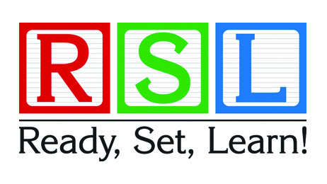
You Are Invited!

Who: Three and four year old children and their parents/caregivers

When: Wednesday May 1st, 2019 at 1:15 pm

Where: East Kensington Elementary
2795 184th Street
Surrey, BC V3Z 9V2
Please call the school office at 604-541-1257 to register

You’re invited to visit our school for this exciting early learning event.

Ready, Set, Learn is an early learning initiative sponsored by the Ministry of Education. It is designed to provide children and parents/caregivers with an opportunity to participate in a series of play-based learning activities within school or community settings. It also provides an opportunity for families to receive information from participating community agencies. Three- and four-year-olds and their families are invited to attend one of the Ready, Set, Learn events held by each school throughout the district.

Ready, Set, Learn dates for 2018-2019
For more information and registration details, please contact the school directly.
Parents/caregivers will receive helpful tips to support their children’s learning and development, as well as information about early learning programs offered by the school district and the community resources available to families.
Resources
- The B.C. Ministry of Education's parent booklet: Ready, Set, Learn: Helping your preschooler get ready for school
(in English).
- The Ministry of Education Ready, Set, Learn website, which includes links to the parent booklet in 11 languages other than English.
- Not sure which school is closest to you? Visit our Locate a School page for district maps and our school locator tool.
Please share this information with anyone
you know who has a three or four-year-old child.

