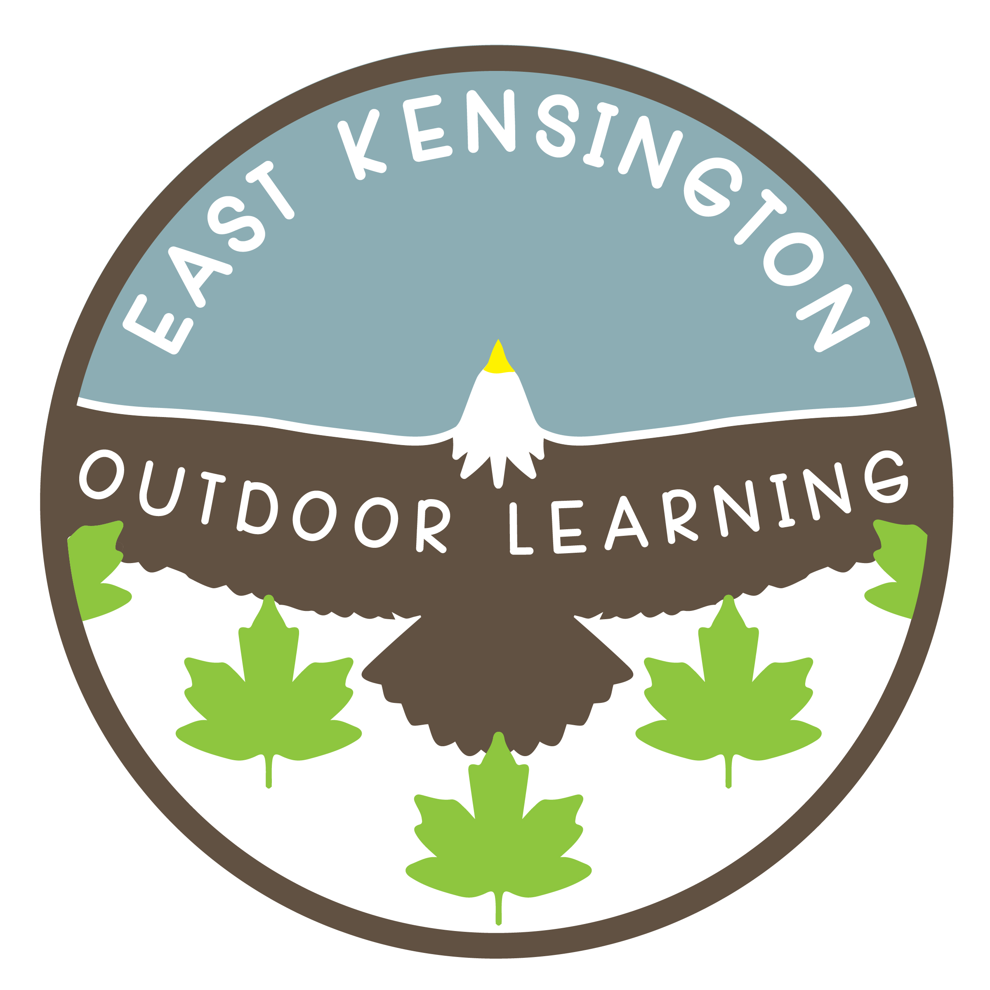
EAST KENSINGTON OUTDOOR LEARNING
2795 – 184th Street, Surrey, BC V3Z 9V2
Phone: (604) 541-1257 Fax: (604) 531-4180
www.surreyschools.ca/schools/eastkensington
Principal: Mr. C. Baldry
Acting Vice Principal: Ms. Alison Leslie

Dear Parents and Families,

As you know, remote learning will continue for all students until June 25th, however schools will also be offering in-class learning beginning on June 1st. In-class learning is optional and the decision of each family. Remote learning will continue through the month of June for those choosing to stay at home as well as on Wednesday’s for all students. No student will be penalized or judged if they are not returning. We will continue to support students whether at home or as we welcome them back to school. In order to assist with our planning, please fill out the attached survey about whether or not your child(ren) are returning to in-class instruction by clicking on the link below. Please complete the survey by Wednesday May 27th, 2020.

https://forms.office.com/Pages/ResponsePage.aspx?id=z-m0CBOBDUK6B1L31N-KzdfSej5npzVLvEsPivEOjFhURDMyMkczMFROSlBERVUwUlJHMkM5QTg1Ry4u

While schools are re-opening, we are still in a pandemic and we are attempting to minimize contact and the spread of COVID. While at school you will see a decrease in class sizes, fewer children in our schools and dramatically increased cleaning.

We are asking families to please monitor the health and symptoms of all of our students who are returning to school. If your child is exhibiting any of the signs or symptoms of the common cold, flu, COVID-19 or other infectious respiratory diseases they are to remain at home. If a child becomes ill at school or shows symptoms or signs of the above, a phone call will be made home for the child to be picked up. This is for the safety and protection of all who come to our building. During this time, our building will still have limits on who has access. We are asking parents to please not enter the building unless you have been asked by a staff member.

Supplies and additional Information:

Our teachers have been in the building to set up their classrooms to meet the new social distance
requirements and as well to pack up all student supplies, work, and miscellaneous items. Families are welcome to come to the school on Friday, May 29th between 10 am – 2pm to pick up these
supplies. We will have the supplies bagged, labelled and set out in the area where your child’s class line up each morning. When you come to pick please adhere to proper social distancing measures as you enter the school grounds and pick up the supplies. If your child is returning to school, your child’s teacher will be sending a detailed letter home by Friday, May 29th, detailing the staggered start and end times as well as the scheduled days your child will attend on, and other pertinent information that you will need to start on Monday or Tuesday of next week.

There will be no sharing of school supplies, resources or class toys during our in-class instructions.
We know this is a lot of information to take in. Please remember that we have never done this before and we are learning together. We know that it will not be perfect, but rather a learning experience towards our ‘new normal’. Please feel free to contact me at the school if you have any questions or concerns. As always, I thank you for your ongoing support.

Sincerely,

Ms. A. Leslie
Acting Vice Principal

leslie_a@surreyschools.ca

