KATZIE NEWSFLASH

6887 – 194A Street, Surrey, BC V4N 1N2
Principal: Mr. Solomon Lee
Vice Principal: Mrs. Lauretta Fenrick
Phone: (778) 571-4080 Fax: (778) 571-4089

https://www.surreyschools.ca/schools/katzie/Pages/default.aspx

New SafeArrival System Starting Monday, April 10th, 2017

SafeArrival will allow parents to report their child’s absence quickly and conveniently in one of three ways:
- Log into the website
sd36.schoolconnects.com
Authenticate Portal account to report absences and update contact information.

2. If you’ve authenticated your account, parents can
download the SafeArrival app (all one word) and log in to report absences

3. Parents can call into an automated interactive telephone system via a toll-free number
1-844-423-1073 through which absences can be reported. Please do not call the school to report absences.

By reporting your child absent in advance using SafeArrival, you will NOT receive an automated call requesting information regarding your childs’ absence.
We will start using our new absence reporting system on Monday, April 10th, 2017.
As of April 10th, all absence and late arrival reporting must go through SafeArrival (web, app or telephone 1-844-423-1073).
Please do not call the school voice mail or send notes to the school or classroom teacher to report an absence or late arrival.
For more information on how SafeArrival works, feel free to watch the following video:
https://www.youtube.com/watch?v=fE82RWB_i9g Thank you for your patience and cooperation during this transition period to better ensure the safety of all our children.

TROUBLESHOOTING
You should have received an email from the SafeArrival system with a temporary password. If you have not received the email, it may be due to our system not having a current email address on file for you.

To Report an email address or a changes to an email address:
Log into Parent Portal by typing the following link into the URL: sd36.schoolconnects.com

Click on: Don’t have an account?
You will be requested to provide the following information. (See reverse for screen shots.)

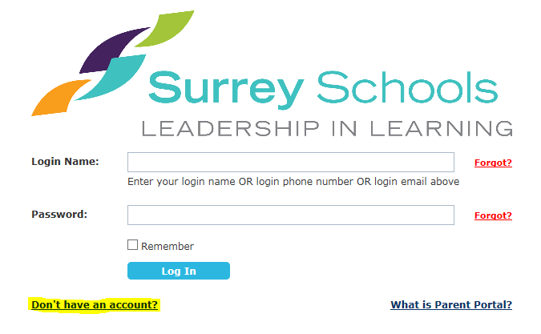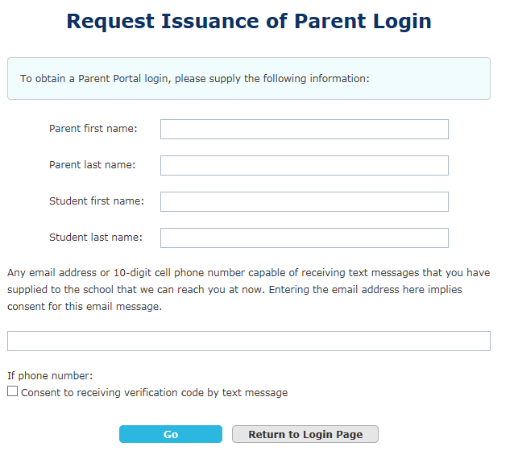

Here is a sample of the email you should have received, if you have not received this please see the Troubleshooting section of this document.

Dear Parents and Guardians:
Thank you for enrolling your child(ren) in a Surrey School District 36 school. Student safety is of paramount importance to us. For the safety of your child(ren), please use our automated student attendance hotline 1-844-423-1073 or SafeArrival Portal website to notify us of all planned absences in advance, including full-day absences, lates and early departures due to vacations, appointments, etc. You can create planned absences in advance for the whole school year. This will help us identify the students whose absences are not planned more quickly and notify their parents as soon as possible.
Our Attendance System is fully automated. Please do not call the school or send notes to a teacher to notify us of a planned absence.
We request that you update your contact information (phone number or e-mail address) by contacting the school.
You can also view or listen to automated telephone and e-mail messages sent to you by the school or the Surrey School District 36 at your convenience.
Your personal login information is as follows:
Login Name: your information will appear here
Phone number: your information will appear here
E-mail address: your information will appear here
Password: your information will appear here
You will need the above information to access the SafeArrival Portal. When you log in for the first time, you must complete an authentication process to ensure the privacy and security of your child(ren). You will receive a verification code by email at the email address listed above. You must type the verification code into the appropriate field on screen to complete the activation process. Please make sure that you have access to your email so that you can receive the verification code.
When you are ready, please click on the link below and begin the authentication process. We recommend you bookmark this link for future use:
http://sd36.schoolconnects.com
If you have an Android or Apple device, you can also download the SafeArrival app. You can go to the Google Play store or the Apple App and search using the keyword "safearrival" (one word) to download the Synrevoice SafeArrival app.
If you have any questions concerning any of the information included in this message, please contact your child's school directly.
Thank you.
*** This e-mail was system generated. Please do not reply. ***

