Sample Post-Secondary Essays

The following essay was written in response to this college essay prompt: tell us about someone who has influenced you.

*****************************************************************************

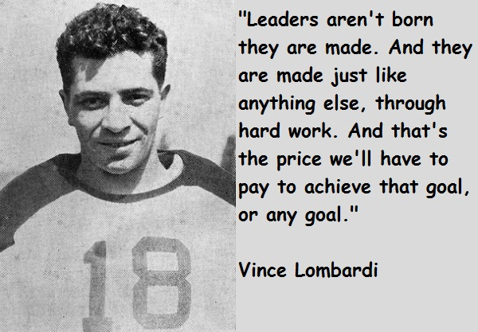

Aunt Rose’s index and middle fingers, swollen and gnarled from rheumatoid arthritis, stop on my 4th vertebrae. The pressure she applies hurt her but brings me relief. I’ve just biked the 6 blocks from my apartment. I am afraid that the police might be coming and I don’t want to be there. The shouts and sounds of flesh hitting flesh are dramatic. The effects of unemployment, alcohol, overloads of prescription drugs prepare my parents for another 15 rounds of a heavyweight and HBO worthy bout. If they could sell it as a reality show it would be limited to adults only. I’m not 18 and I need to leave.

Aunt Rose will hum and press bone, she will tell me again how I need to take AP math even if I never do more than simple addition as a public defender a few years ahead in my future. Aunt Rose never went to college but she knows how to heal wounds that come from words instead of fists. When my father tells me to get my fat ass out of his chair or my mom says to stop studying and get a job to help the family instead of just myself I my spirit and soul both bleed. Aunt Rose may not be a doctor but she knows how to heal.

Aunt Rose left southern rural Georgia when she finished high school to escape the racism and limitations of that part of world that seems to me like ancient history. But poverty is as much alive today as it was back then. She ended up working as a bank teller in Detroit until she retired two years ago. Her job since then has been telling me stories and keeping me focused on escaping the cycle of poverty that now includes the city itself. She had a husband who sat around with friends and drank and smoked and not much else. But she loved him and kept him and buried him. She taught me that love is not the movies or what the boys say to get me to do things they want. She’s kept me from having kids at a time when I was still a kid. She tells me I still am.

Aunt Rose tells me that I need to love my country, my president, and my race. She tells me all this every time I go over to see her with my tears. I don’t have anything else to give her sometimes. Aunt Rose wants me to get the chance she never had. She worked for 30 years around money but never made much. She wants me to go to a school that will prepare me for stability—financial and emotional. Each year Aunt Rose added some money to a fund and compound interest kicked in. That lesson in addition and economics will help pay for my education over the next four years.

Her fingers stop, the knotted pressure is gone. My tears are gone too until a new installment of my own personal Game of Thrones shows me again the hard life of peasants and parents whipped by fate. I turn and tell Aunt Rose I will make her proud. Aunt Rose smiles and says, “I know you will child, I know you will.” But her eyes are also wet when she says it even as she smiles. And these words mean more than anything I have read in a book or anything I have heard from Nobel winners or other geniuses. Her enduring belief has made me learn to work, to love setting goals, and to make it in life, so I can be like her some day—helping those who need it and who don’t have other places to turn.

Is this an effective essay to submit to a highly selective college or university? Why or why not?

If you had to describe, using concrete details, the person who wrote this essay, what would you say?

If you had to choose one person to admit based upon the essay would you admit this one or the one whose essay I posted last week?

Grit has now become the hottest meme that many selective schools highlight when they discuss who stands out in a huge pool of wonderful students.

