Science 9 Course Outline
Name _______________________
Block ______
  - Panorama Ridge Secondary School
Date_________________
  - Mr. Sidhu Room B202
Sidhu_Sim@surreyschools.ca
Welcome to Mr. Sidhu’s Science 9 class. The purpose of this course is to further your scientific understanding of your environment, and gain scientific literacy and skills to better understand and appreciate the world in which we live.
Science 9 is split into 4 ‘Big Ideas’ where we will develop Inquiry and critical thinking skills within these

Content Areas:

Cells are derived from cells (Biology) | The electron arrangement of atoms impacts their chemical nature (Chemistry)
In this unit we will answer questions like:  - How do cells reproduce?  - How do different types of organisms reproduce?  - What is the difference between having one parent, and having two parents?  - What are the advantages and disadvantages of the different types of reproduction?  - Is one type ‘better’ than another?  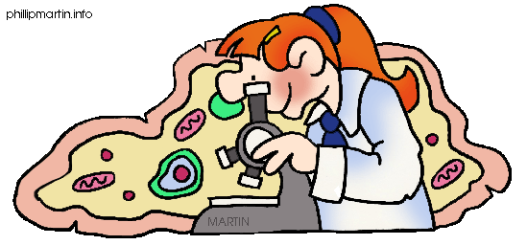 | In this unit, we will answer questions like:  - What are ‘elements’?  - What makes one element different from the other?  - How are they organized?  - How do we predict their properties?  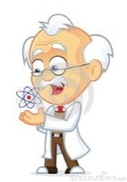  - What is the ‘Periodic Table’ and how do we read it?  - What happens if we combine different elements together?  - How can we predict which elements will combine?  - What are the names and formulas of compounds?
Electric current is the flow of electric charge (Physics) | The biosphere, geosphere, hydrosphere and atmosphere are interconnected as matter cycles and energy flows through them (Earth science)
In this unit, we will answer questions like:  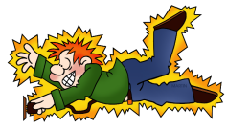  - What is ‘electricity’?  - How do we measure electricity?  - What is ‘Ohm’s law?  - How do we make a working circuit?  - What are the parts of the circuit?  - What is the difference between a ‘parallel’ and ‘series’ circuit?  - How does one make a ‘short circuit’?  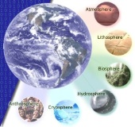  - What are the hazards of electricity and how can we be safe around it? | In this unit, we will answer questions like:  - What does the sun do for us? How does it affect the cycle of matter and energy through our planet?  - How do different living and non-living things work together in the water, land and air?  - What happens if one of these living or non-living things is out of balance? How does that affect all the other elements?  - How are nutrients (carbon, nitrogen, phosphorus) and energy cycled in an ecosystem?  - What happens if the nutrients are out of balance?  - How have human activities affected the natural balances and cycles of matter and energy?  - What are the short and long term effects?  - What are some solutions to fix the damage?

Through the year as we learn the content, we will be developing skills such as:

Questioning and Predicting | Planning and Conducting
- Making observations about your environment  - Ask a question that you would like to find the answer to  - Make a hypothesis (a possible answer to your question) using an ‘If…then’ statement  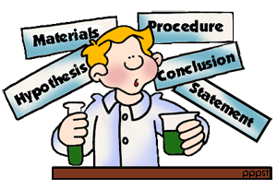  - Make predictions about the answer to your question | - Come up with a well designed, fair experiment to test your hypothesis  - Recognize potential risks and ethical/cultural, and/or environmental issues with the experiment methods  - Conduct your experiment safety and ethically  - Collect/record reliable data (qualitative and quantitative) with appropriate equipment
Processing and analyzing data and information | Evaluating
- Construct, analyze and interpret data in different forms (eg. Graphs, models, diagrams)  - Identify and analyze patterns and trends in the data from information collected; describe relationships between variables  - Identify any inconsistencies (things that don’t ‘fit’ or make sense)  - Be able to draw and apply data from different sources including ‘First Peoples’ perspectives and knowledge.  - Draw conclusions and identify relationships (what did your data tell you?)  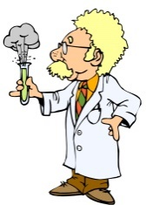  - Analyze cause/effect relationships (eg. If ‘this’ changes, how will it affect ‘that’?) | - Reflect on investigation methods:  - Were there any problems with my experiment design?  - Was my data accurate?  - Where there any sources of error?  - What could be done better next time?  - Where can I do with this information, why is it important?  - Could there be another explanation for this outcome?  - Did I influence the outcome in any way unintentionally? Is my data and research reliable and valid?  - How do I know that my sources of information are reliable? How do I know something is ‘true’?  - Is a model the ‘only’ or ‘best’ way to understand something? What does it miss?  - How would my counterpart 100 years ago study and understand this? How has technology made this easier for me?
Applying and Innovating | Communicating
- Work with others to design projects and solve problems; help to find ways to fix problems in your community or globally – how do scientists usually help to solve problems in the world?  - Apply what you learned to new situations and other problems  - Express new ideas to solve problems | - Pick a concept and make a model to explain it  - Communicate your scientific ideas and information for a selected audience using proper language, models, and well-constructed arguments.

Supplies Needed:

- A 2 inch, 3 – ring binder with paper and dividers. *** No other subject should be included in this binder

*** How you organize your binder is up to you (i.e. by chapter, assignment type, etc), but it MUST be organized in order to facilitate your success!! ***

I suggest the following: 5 dividers with the following sections:

- Notes  - Homework/warmups  - Labs/assignments | - Quizzes/tests  - Scrapwork

    - Pencils, pens (blue and red), eraser
    - scientific calculator
    - ruler
    - Agenda/Thunder App

*****Please bring ALL these supplies to EVERY class. Students will NOT be allowed to return to their lockers to get supplies after the bell goes!*****

Note - there will be no assigned textbook for this course, study materials and notes will be provided throughout the course.

Evaluation:

Each of the 4 units will be worth 25% of your Class mark. Your percentages will be calculated based on quizzes, tests, and summative labs/projects. The labs and projects will work on developing skills as well as applying concepts learned in class.
To help students assess their own learning, they are encouraged to reflect on the following:
- Where am I now with my learning?
- Where do I want to get to with my learning?
- What do I need to do to get better?

A  86% + | Has deep understanding of the content, exceeds expectations of learning standards, sees possibilities and is able to innovate.
B  73% - 85% | Has deep understanding of the content, routinely meets acceptable learning standards, initiates, plans and can follow through to completion.
C+  67% - 72% | Has a good working knowledge of the content, able to achieve most tasks using own judgment but requires assistance when problems occur.
C  60% - 66% | Has a working knowledge of key aspects of the content, completes straightforward tasks to an acceptable standard, some assistance needed for complex tasks.
C-  50% - 59% | Minimal understanding of the content, adherence to taught rules or framework, requires some assistance to complete most tasks.
I or F  Below 50% | Not demonstrating minimal understanding of the content, cannot complete tasks even with assistance, possibly as a result of poor attendance.

The final grade will be a combination of the class mark (worth 80% of the final mark), and a final assessment (worth 20%)

