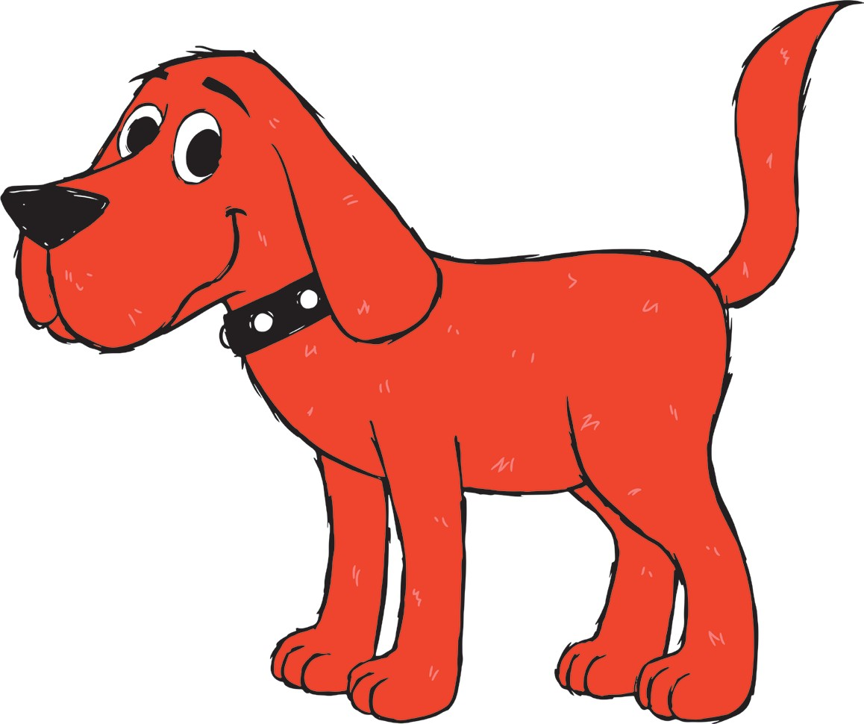
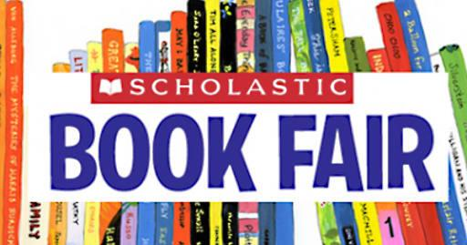
WHEN: Monday, April 4th to Friday, April 8th
WHERE: Katzie Elementary Library for staff and students & online for parents and caregivers
Dear Katzie Families,
The fun and excitement of a Scholastic Book Fair is coming to Katzie Elementary! The Scholastic Book Fair is an annual library fundraising event that students look forward to each year. It is a chance to promote literacy, encourage reading, and provide access to the latest books. Every dollar spent helps earn rewards for our school library to purchase books and other resources.
Book Fair Format
To mitigate the risks of Covid spread and to adhere to District guidelines, we will be running a hybrid Book Fair with a combination of online and in person shopping. The Book Fair will be only open to classes for shopping during their scheduled library time. It will be closed during recess, lunch, before and after school. This is to avoid large numbers of people from different classes congregating. Sadly, this also means that parents and other family members will not be able to attend this year.
We are also offering a Virtual Book Fair running the same week so that families are able to shop together online from home. Use the link below or scan the QR code to access the online fair. Online orders must be placed before midnight on April 8th. They will be shipped to our school free of charge and delivered to students in their classes the week following the Book Fair.
Before our Book Fair begins, visit the link to:
- SAVE it to your browser
- WATCH videos of popular new titles
- PREVIEW featured books

https://virtualbookfairs.scholastic.ca/pages/5164989
In-School Fair
Our in-school Book Fair will only be accepting cash payments. Please ensure you send your child with an amount of money you feel comfortable with them spending. A small Ziploc bag would be a good idea to carry money in and any change they may receive. There is also a wish list in the promotional flyer “Books I Want to Read” that you can fill in, cut out and send along with their money.

Book Fair Class Time Slots
Please ensure you know your child(ren)’s book fair time slot, so they don’t miss it. K-3 classes will have their usual Library class day and time. However, some Intermediate classes may have a different day/time. Classroom teachers will be given this information and communicate it to you. The schedule has been adjusted to give our Intermediate classes 30 minutes to shop instead of their usual 20 minute book exchange time slot. If your child is absent on that day and would like to make an in-school purchase, please send money with them when they are back and have their classroom teacher contact us. We will make arrangements to get them in at an alternate time.
For our Kindergarten and Grade 1 students especially, this will likely be the first time they have ever seen or experienced a Book Fair. We understand that without their parents present, the idea of sending cash with them may be intimidating. This is in part why we have a virtual fair option as a safer alternative. However, rest assured that the Librarian(s) and a few volunteers will be present to supervise and help students shop.
Novelty Items & Price Guide
In addition to books, the Book Fair offers popular novelty items such as pencils, erasers, key chains, and posters that always attract a lot of attention. Please have a discussion with your child about what you would like to see them purchase so there are no surprises.
As a guide, this is the approximate price range for book fair items:
- Pencils & Erasers - $0.50
- Bookmarks - $0.75
- Speciality Erasers - $1.00 - $3.50
- Speciality Pencils - $2.00 - $5.50
- Mini Backpack Key Chains - $8.00
- Other Specialty Items - $8.00 - $14.00
- Posters - $5.00
- Paperback books - $5 - $15
- Hard Cover books - $15 - $25
You can visit the online fair to get a better idea of specific prices. Visit the link or scan the QR code on the previous page.
Please note that some items at the in-school Book Fair might not be available online and vice versa.
Thank you very much for your support. While we know this year looks a bit different, we feel this format is the safest option given the current climate and better than not having a Book Fair at all. We sincerely hope to have a return to a normal fair next year. Happy Reading!
Your Friendly Teacher-Librarians,
Ms.Van Santen & Ms. Aslam
