Strawberry Foldovers

315 mL Flour
5 mL Instant yeast
30 mL Sugar
1.5 mL Salt
2 mL Grated lemon zest
60 mL Margarine
15 mL Water
50 mL Milk
15 mL Egg

DAY 1:
1) In a large bowl combine 250 mL flour, sugar, yeast, salt and lemon zest.

2) Warm milk, water and margarine until very warm,but not boiling. Gradually
add to flour mixture.

3) Add egg and mix well.

4) Add remaining flour to make a stiff batter.

5) Cover with saran wrap and label with names and block.

DAY 2:
Filling:
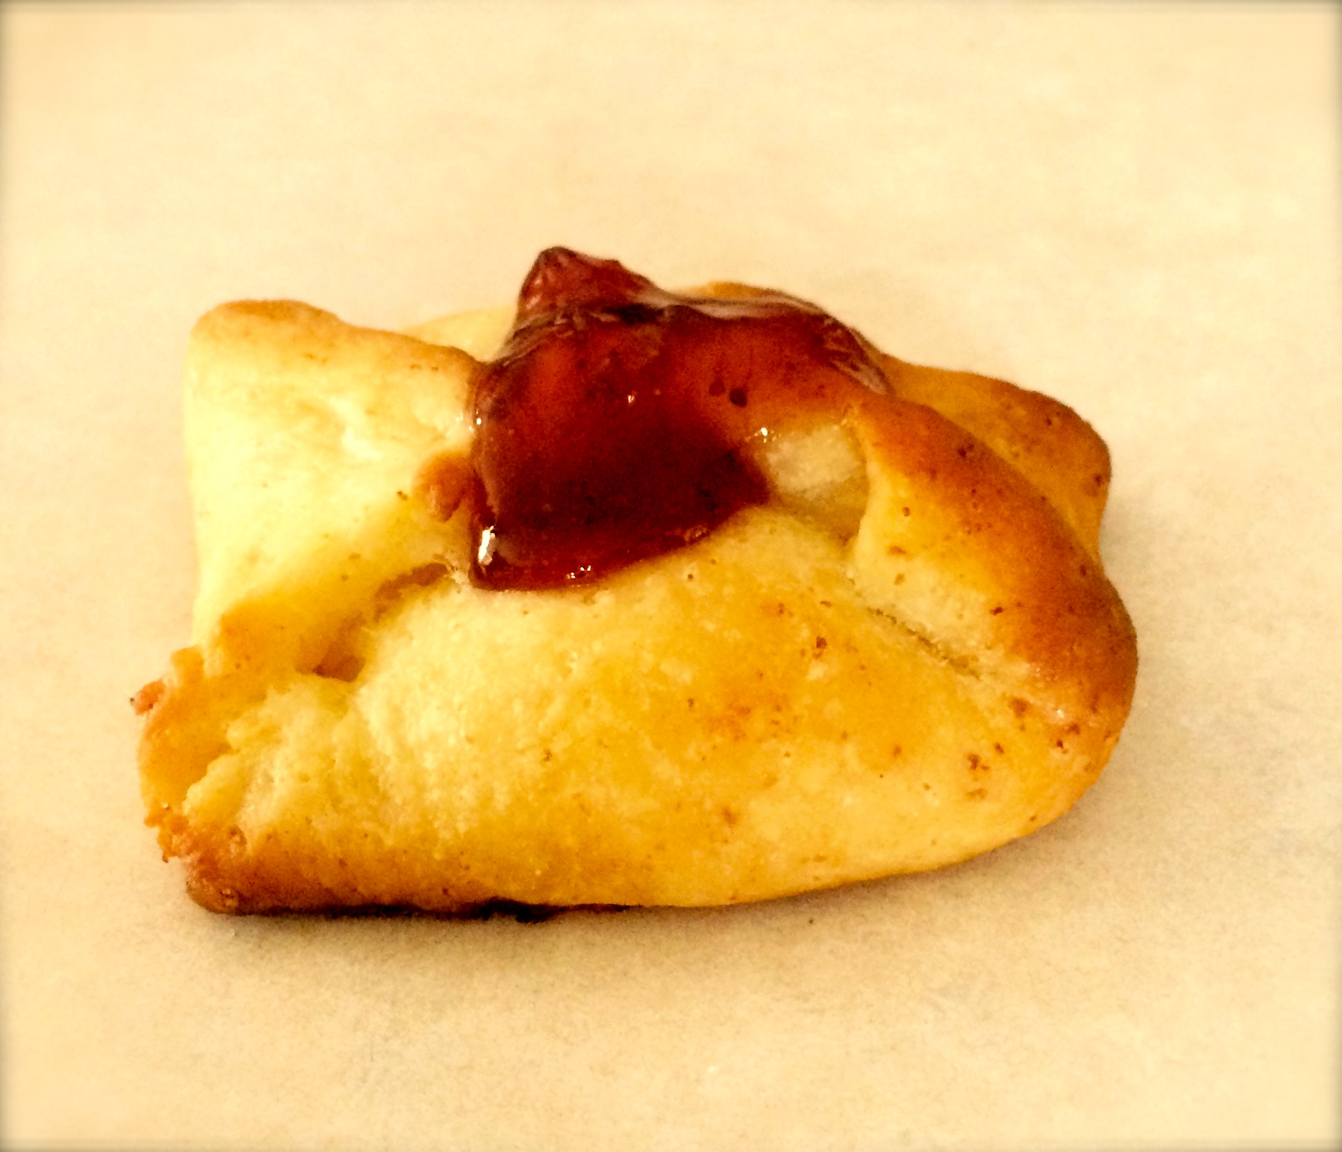
1/4 250g package cream cheese
30 mL Sugar
5 mL Egg yolk
10 mL Flour
5 mL Lemon juice
0.5 mL Lemon zest
60 mL Strawberry jam

- Preheat oven to 375° F. Line a jellyroll pan with parchment paper.

- In a medium bowl, combine cream cheese, sugar and beat until light and fluffy. Add egg yolk, flour, lemon juice and lemon zest, stirring until smooth.

- Roll dough to a 12 inch square and cut into 12 equal squares (approximately 3 inches in size).

- Place squares on parchment lined cookie sheet. Put
5 mL of filling in the centre of each square. Bring opposite corners to center, overlap slightly and pinch together.

- Brush with egg white glaze (egg white + 5mL water) and bake for 10-15 minutes or until golden.

6) Heat jam for 15 seconds in microwave and spoon over hot pastries. Cool on wire rack.

Demo Questions:

1) What is the function of yeast in this recipe?

2) How long do you knead the dough for? Why?

