Things to Remember
Every Day is Earth Day,
If it's cold or wet or hot
Pitch in to save the planet
It's the only one we've got.

Health & Safety Tip for Parents

Most injuries to children happen when parents are tired, hungry, or during times of excess stress. Taking care of yourself is a vital part of keeping your child safe. Recognize these signs and . . . take good care of yourself.

Holly Elementary StrongStart Newsletter

Welcome Back!
Welcome back everyone. I hope you all enjoyed your two week spring break, spending quality time with family and friends.
This month, we will be enjoying all that spring has for us. Spring is the start of new beginnings - baby animals, grass, plants, flowers, and much more. Everywhere you look, things are growing and changing. It is an exciting time for curious minds to notice and explore. We will be doing plenty of that in the classroom this month.
Also, Earth Day is Friday, April 22. Think of ways we can help keep our planet clean.

Ready, Set, Learn, Thrive!
Please join us at the Guildford Rec. Centre for this special community event for 3-5 year olds and their parents/caregivers.
Date: Wednesday, April 6, 2016
Location: 15105 105 Ave
Surrey
Time: 9:30am-11am
StrongStart will be closed on this day.
Let’s get ready, set, learn, and thrive!

APRIL 2016 Volume 3, Issue 8

Holly Elementary
10719 - 150 Street  Surrey, BC V3R 4C8  Phone: 604-585-2566  Fax: 604-581-1783 | 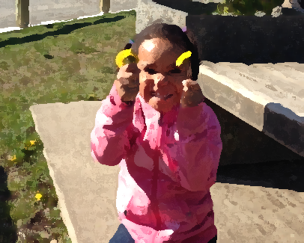
StrongStart Hours:
(M-F) 8:30 - 11:30 am

Principal: Andrew Shook
Vice-Principal: Brad Issel
StrongStart Facilitator: Michelle McKenzie

Surrey Schools on the Web!
www.surreyschools.ca

Holly Elementary on the web!
www.surreyschools.ca/schools/holly

Upcoming Events

Apr. 4 StrongStart Closed

Apr. 6 Ready, Set, Learn, Thrive!
Guildford Rec. Centre
StrongStart Closed

Apr.18, 2016 Pro-D – StrongStart Closed

Apr. 22 Earth Day
(Special Activity)
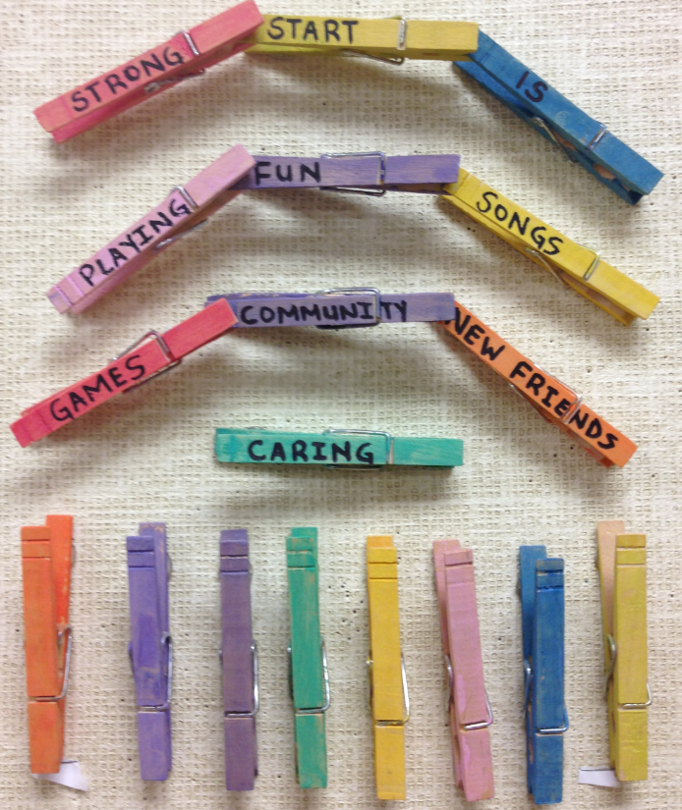

APRIL 2016
Sunday | Monday | Tuesday | Wednesday | Thursday | Friday | Saturday
 |  |  |  |  | 1  Gym  10:10-10:25am | 2
3 | 4  PROGRAM  Closed | 5  Gym  10:10-  10:25am | 6 CLOSED  Ready, Set,  Learn  Guildford Rec. Centre 9:00am | 7  Gym  10:10-10:25am | 8  4/5 Yr. Olds  Join Kindergarteners in Holly Library  9am | 9
10 | 11  Gym  10:10-  10:25am | 12  Gym  10:10-  10:25am | 13  Gym  10:10-  10:25am | 14  Gym  10:10-  10:25am | 15 | 16
17 | 18  Pro-D Day – StrongStart Closed | 19  Gym | 20  Gym | 21  Gym | 22  4/5 Yr. Olds Join Kindergarteners  In Holly Library  9am | 23
24 | 25  Gym | 26  Gym | 27  Gym | 28  Gym | 29 | 30

