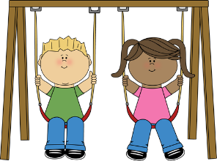
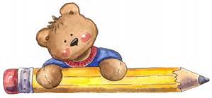

Upcoming Events

May 6 Professional Development Day – StrongStart Closed

May 23 VICTORIA DAY – StrongStart Closed

May 27 PALS – Numeracy (9:00 am)

May 30 Professional Development Day – StrongStart Closed

Holly Elementary
10719 - 150 Street
Surrey, BC V3R 4C8
Phone: 604-585-2566
Fax: 604-581-1783

StrongStart Hours:
(M-F) 8:30 - 11:30 am

Principal: Andrew Shook
Vice-Principal: Brad Issel
StrongStart Facilitator: Michelle McKenzie

Surrey Schools on the Web!
www.surreyschools.ca

Holly Elementary on the Web!
www.surreyschools.ca/schools/holly
Holly Elementary
StrongStart Newsletter

MAY 2016 Volume 3, Issue 9

What’s Happening in May?
It is amazing how quickly April has come and gone. Time flies when you’re having fun!
May is the time for the Surrey International Children’s Festival at Surrey Arts Centre & Bear Creek Park. This is a wonderful opportunity to spend some quality family time together. This year, the festival runs Thursday, May 26 – Saturday, May 28rd.
One of my favourite performers, Charlotte Diamond, will be there!
For more information, go online at: www.surrey.ca/childrensfestival
Arts Centre Box Office: 604-501-5566
Festival info line: 604-501-5598

PALS Session #3: NUMERACY
On Friday, May 27, we will have our final PALS (Parents as Literacy Supporters) session of the year. It will be all about Math! Please sign up at the entrance of StrongStart. This is for our 3-5 year olds only. Kindergarten teacher, Mrs. Peterson, will accompany us that day. The session begins at 9 and ends at 11:30am.

Things to Remember
Those children attending Kindergarten at Holly in September should have received an invitation to “Welcome to Kindergarten” (Thursday, May 19). Let me know if you have not received an invite.

Health & Safety Tip
Swing Safety

Swings are the most frequent source of injury at a playground. Be sure to have your child SIT on the swing and HOLD TIGHTLY with both hands.

MAY
Sunday | Monday | Tuesday | Wednesday | Thursday | Friday | Saturday
1 | 2  No Gym | 3  No Gym  (Art Crawl) | 4  No Gym  (Art Crawl) | 5  Gym | 6  Professional Development Day  StrongStart Closed | 7
8 | 9  Gym | 10  Gym | 11  Gym | 12  Gym | 13 | 14
15 | 16  Gym | 17  Gym | 18  Gym | 19 StrongStart  OPEN  WELCOME TO KINDERGARTEN  (Holly students) | 20 | 21
22 | 23 VICTORIA DAY  StrongStart  Closed | 24  Gym | 25  Gym | 26  Gym  Children’s Festival  Bear Creek  Park | 27  Children’s Festival  PALS  (3-5 YR OLDS)  9:00am | 28  Children’s Festival
29 | 30  Professional Development Day  StrongStart Closed | 31  Gym

