STUDENT INFORMATION PORTAL

On Dec 5, 2018, parents will be able to access the Term 1 REPORT CARD
for the 2018/2019 School year.

The Student/Parent Portal allows students and parents to access personal educational Information. Through the Portal, students and parents can access valuable educational information and such as transcripts, report cards, attendance records, Course Requests, timetables etc. Students and Parents will be required a Login ID and Password to access their information. If you have forgotten your login information, please contact the office at 604-588-3418. Please note: We require a current email address in order for you to have already received your login information.

STUDENT INFORMATION PORTAL
On Dec 5, You can access the Student Information Portal to see your child's Report Card.
- See the detailed Portal Access instructions HERE
If we have your email address, you are automatically registered for the Portal. Your login information was sent to your email from our "SYSADMIN”.
If you have not received the log in information email, please check you junk or spam folder or deleted items folder. If you still can’t find your verification email, please follow the red instructions below.
PLEASE NOTE: If you are unable to sign in after two attempts, you will be locked out on the third try. After two failed attempts, you must reset your password through the link that reads "I forgot my password". Doing this will send a new password to your email address. If you happen to get locked out, please email the school at lamatheson@surreyschools.ca or phone 604-588-3418 to request the system admin to reset your password.

IMPORTANT: We must have your email address to allow you to access the Portal. Please email the school at lamatheson@surreyschools.ca to update your information if we do not have it. Once you send us your email address, it takes about a week to update the system before a verification email with a temporary password will be sent to you.
Within that week, please monitor your inbox and spam folders for an email from SYSADMIN.

Step By Step Login information is on the next page:

Step By Step Login information

Student Login  - https://www.myeducation.gov.bc.ca/aspen/logon.do  Enter in your student number  Your password is case sensitive and requires at least one symbol.  Example: April3$2003  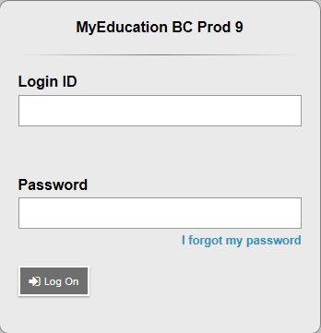  Click here if you can’t remember your password.  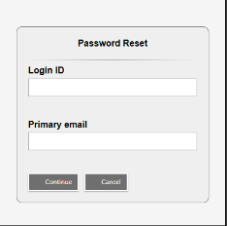  - If you forgot your password then click “I forgot my password”, a screen like this will appear  Enter in your student number  Enter in your email that you used to register for MyEd. Most students will have used their Surrey schools email as their primary email.  - MyEd will ask you for the answer to a security question. If your answer is correct then an email with your new login ID and password will be sent to your primary email.  - If you cannot reset your password then please see the secretary at the office and ask them to reset it at the district level because password reset is not working. | Parent Login  - https://www.myeducation.gov.bc.ca/aspen/logon.do  - Your Login ID and password should have been sent to the email address that you registered with the school.  Enter in your login ID  Your password is case sensitive and requires at least one symbol.  Example: April3$2003  Click here if you can’t remember your password.  - If you forgot your password then click “I forgot my password” to start the password recovery.  - If you cannot reset your password then please call the school and we will place in a work order to have it reset.

