**NEWSLETTER #2 SEPTEMBER 8, 2020**

**MESSAGE FROM MRS. STARK**

On behalf of the entire staff, we would like to welcome all our students and

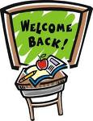**FIRST WEEK- September 3-6th**

their families to the new school year at Sullivan Elementary. We hope

that everyone enjoyed family time, sunshine and laughter together this past

summer. We are looking forward to working with you and your children this

year as we continue to build our positive, engaged, and connected school community!

**Back to School Start Up Information**

First Week Schedule

Below is the schedule for the first week **only for students who are returning to school full time in person**. 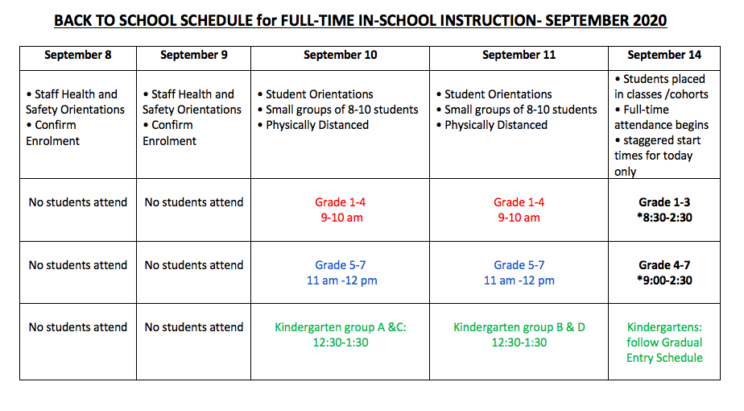

**Grade Group Meeting Locations for September 10 & 11**

**Grade 1-4 attend from 9-10 both days:**

GRADE 1 GARDEN

GRADE 2 PLAYGROUND

GRADE 3 SWINGS

GRADE 4 GRASS FIELD

**Grade 5-7 attend from 11-12 both days**

GRADE 5- PLAYGROUND

GRADE 6- SWINGS

GRADE 7- GRASS FIELD

**Kindergartens attend: PLEASE MEET AT THE PLAYGROUND**

September 10 Groups A 12:30-1:30pm

September 11 Groups B 12:30-1:30pm

**STUDENT ORIENTATION (IN-PERSON INSTRUCTION)**

During the student orientations you can expect a warm welcome back from our staff who will provide an opportunity to re-establish school connections, relationships and a sense of belonging! During these orientations, students will be organized into groups of 10 or less, and will maintain physical distance.

We will also cover important health and safety topics and information about new school routines including:

* Reassurance and kindness from our staff
* Welcome, ease concerns
* Classes/learning groups
* Physical distancing
* Masks
* Hand washing
* Arrival and dismissal
* Washroom procedures
* Play areas
* Lunch procedures
* Safety

**RETURN TO SCHOOL SAFETY PLANNING**

Here are some of the ways we are planning for a safe return to school:

* Please be reminded that **parents and caregivers are responsible to assess their child(ren) each day before going to school.**If your child is experiencing symptoms of common cold, influenza, COVID-19 or other infectious respiratory disease please **keep your child home until there has been an assessment by a health care provider AND the symptoms have resolved.**
* All students, staff and family members must stay home if they are sick and not enter the school building.
* Physical distancing and minimizing physical contact expectations.
* Regular, scheduled hand washing and hand sanitizing.
* Reduced and directional hallway traffic – keep right.
* Students will be organized into classes/learning groups and anyone working with students outside of these groups will be expected to wear a mask and/or maintain physical distance.
* Masks worn outside of cohort, in common areas and optional within cohort.
* Each student and staff member will receive two re-usable masks.
* Students will learn to follow good hygiene practices (wash hands frequently, cough into elbow, avoid physical contact, maintain social distance, etc.).
* No large gatherings - assemblies, school events, etc. will not be happening or will be shared digitally.
* Increased outdoor learning and play (dress appropriately for the weather).
* Limited shared materials.
* Excess furniture and resources removed from classrooms to create more space.
* Fabric items removed from classrooms if possible.
* Regular cleaning and disinfecting of high-touch surfaces by daytime caretaker in addition to regular cleaning.
* No sharing of food including snacks, lunch, birthday treats.

**Important School Procedures and Routines**

* Access to our building will be limited to students and staff, unless prior arrangements have been made through the office. Should you need to need to contact the school, please phone the office at 604-597-1977 or email the school at [sullivan@surreyschools.ca](mailto:sullivan@surreyschools.ca)
* The front door of the school will remain closed. Parents/visitors are not able to come in to the school.  If you need assistance, please phone or email.
* No items/lunch should be dropped off at the office during the school day.  Please send lunch to school with your child(ren) in the morning.
* Students and families who are not attending school should not be on the school property during school hours
* Students will be going outside rain or shine every day, so please dress appropriately for all weather.

**CLASS PLACEMENTS AND STAFFING**

As you can imagine, the new options for return to school will have an impact upon staff assignments, student placements, and class organization plans. We ask for your patience and understanding as we place students into classes and cohorts. As students many not move across cohorts once placed, we will be unable to make any changes. Students will begin in their classes on Monday, September 14.

**SCHOOL SUPPLIES**

School Supply lists for Grades 1-7 are posted on our website under the ‘Parents’ tab. Students will not need to bring any supplies for the first days next week.

Kindergarten teachers will collect money from each student to cover the cost of school supplies for the whole school year. This money can be paid on-line through our school website.

**BLENDED TRANSITION PROGRAM**

If you have registered your child for ‘Surrey-Blended Transition program’ you DO NOT ATTEND THIS WEEK. Your orientation will be the week of September 14 with a start date of Sept 21. **You must be registered on the district site for the Blended-Transition Program by 4pm on September 8.**

**\*Please note: If you registered for the Blended Transition Program, you may change to full-time in-person instruction by 4:00 on Tuesday. Please call the office to let us know or if you have any questions we can answer to help with your decision.**

**ALLERGY AWARENESS**

Several Sullivan students have severe anaphylactic reactions to peanuts, nuts and their by-products. Please do not send foods to school that contain these products. Children will not be sharing any food and will be washing their hands carefully after eating if there is an anaphylactic student in your child’s classroom. Thank you for your continued understanding and cooperation as we endeavour to make our school a safe environment for all students.

** **Please inform the school immediately if your child has a severe life-threatening allergy so we can ensure appropriate procedures are in place.**

**STAY CONNECTED WITH SULLIVAN - WEBSITE, SCHOOL LINK APP, EMAIL , TWITTER**

**WEBSITE**: Our school website is the official source for information about the school. The website will be updated regularly and all important information will be located here. Please make sure to bookmark our school home page at [www.surreyschools.ca/sullivan](http://www.surreyschools.ca/sullivan)

**SCHOOL LINK APP**: Go to the app store to get the free ‘schoollink’ app (iphone and android). Choose to follow Sullivan. Turn on all notifications and you will receive updates directly to your phone each time the school website has been updated.

**SCHOOL EMAIL LIST:** One of the great features of our website is the ‘subscribe to email list’. Go to the home page and enter your email address to receive important emails from the school and district. Be sure to click on the link sent to your email to complete the sign up (may need to check junk folder)

**TWITTER**: We are also on Twitter! Follow us @sullivanElearns for brief updates and information about what’s going on at Sullivan.

**All school information and important updates will be posted on the school website**. Be sure to stay connected by getting the app, joining our email list and checking our website regularly.

**SULLIVAN BELL SCHEDULE 2020-21**

**(*please note: we may have staggered recess and lunch times, depending on the number of students attending-start and end times will NOT change*)**

8:30 am Welcome bell rings

8:35 am Second morning bell rings



Morning session

10:15-10:30 am Recess

Morning session continues

11:50 am-12:05 pm Students eat lunch in classrooms

12:05-12:35 pm Students play outside

12:35 pm Afternoon bell rings

Afternoon session

2:35 pm Dismissal

2:45 pm Supervision ends

**Drop Off**

* Please walk to school if possible, as parking is at a premium for staff and construction workers. If you have to drive, please park a block away and walk the remainder.
* Please Do NOT arrive before 8:25

**Pick up**

* Student must be picked up at their classroom door at 2:30 pm promptly, or leave right away if they are walking home. Avoid large groups socializing at the playground if possible.
* Students may not be picked up before 2:30 (unless previously arranged)