The Ultimate Kinder-Ready Kid!

You know your child is ready for kindergarten when they can say:
I can put on my own jacket and rain pants.

I can turn my sleeves and pant legs right side out.

I can carry my own backpack and belongings.

I can zip up my jacket and backpack.

I can pack my own backpack.

I can put away my toys and materials.

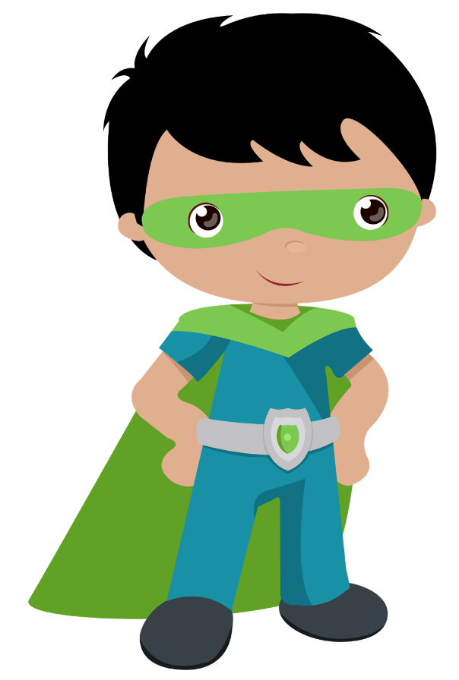
I can tell when I have to go to the bathroom and toilet myself.
I can tell when I am hungry, full or thirsty and get what I need.

I can eat a snack and put away my containers within a 15-minute time frame.

I can write my name using upper- and lower-case letters.

I can count to 5.

I can use a glue stick.

I can share and take turns with others.

I can open all my lunch containers.

I can properly use a pencil, a crayon and scissors.

I can use a Growth Mindset to help me persevere.

I can communicate my needs.

I can follow 2- step oral instructions.

