Dear Strawberry Hill Families,
We hope you had a wonderful summer and enjoyed the sunshine. We are excited to be welcoming students and families back to school on Tuesday, September 2, 2025. Below are some details about the first day and week ahead.
This fall, we’ll be trying something new. In previous years, students were placed in temporary grade groupings until permanent class placements were finalized. This September, instead of starting in temporary grade groups, students will return to their teacher from last school year.

We believe this change will provide a more comfortable and familiar start for students, help teachers support the transition more smoothly, and make communication easier for families during the first few days of school.

New students joining our school will go to the gymnasium on the first day, where staff will greet them and help them get settled. These students will be placed into temporary classes and will move into their permanent classrooms once final placements are complete.

Once all class lists are finalized, students will be moved into their new classrooms with their new teachers. We will work as quickly as possible to form classes, but this process could take until Friday or longer, as we must wait for district approval of our classroom organizations. We appreciate your patience and understanding during this time.

Thank you for your continued support. We’re excited for the year ahead!

Tuesday, September 2nd
- Kindergarten students will attend from 10:00 – 10:30 am and will meet at the front of the school. Please see map below.
- Grade 1 – 7 students attend for ONE hour from 10 am – 11 am. Students will return to their last years teachers. It is important for us to have an accurate count of how many students will attend Strawberry Hill Elementary to plan classes for this school year. If you plan to attend our school, but will not be able to be here September 2, please call the school office (604-596-5533) to let us know.
- Below you will find a map that shows the gymnasium and where Kindergarten attendance will be taken.
- Students DO NOT need any school supplies for the first day.

Wednesday, September 3 – Friday, September 5
- Kindergarten students please follow the Gradual Entry schedule that was emailed out to families in the summer. If you did not receive a package, please call the school (604-596-5533).
- 8:37 am – 2:30 pm - Grade 1 – 7 students will return to last year’s teacher. These classes are temporary.
- Students DO NOT need their full school supplies for this first week. Teachers will let students know what supplies they need on Tuesday.
- If you ordered supplies from School Start, they will be distributed to students by teachers sometime during the first week of school.
- Grade 1 – 7 students will be at school for the full day. Please pack a healthy snack, lunch and water bottle and dress for the weather. Below is the bell schedule for the day.

First Day: September 2nd only one hour 10 am -11 am
Kindergarten only 10:30 am – 11 am

See regular Bell Schedule below for rest of the year:

2025-2026 Bell Schedule

Welcome Bell | 8:32 a.m.
Morning Classes Begin | 8:37 a.m. – 10:15 a.m.
Recess | 10:15 a.m. – 10:30 a.m.
Morning Classes | 10:30 a.m. – 11:45 a.m.
Lunch | 11:45 a.m. – 12:30 p.m.
Afternoon Classes | 12:30 p.m. – 2:30 p.m.

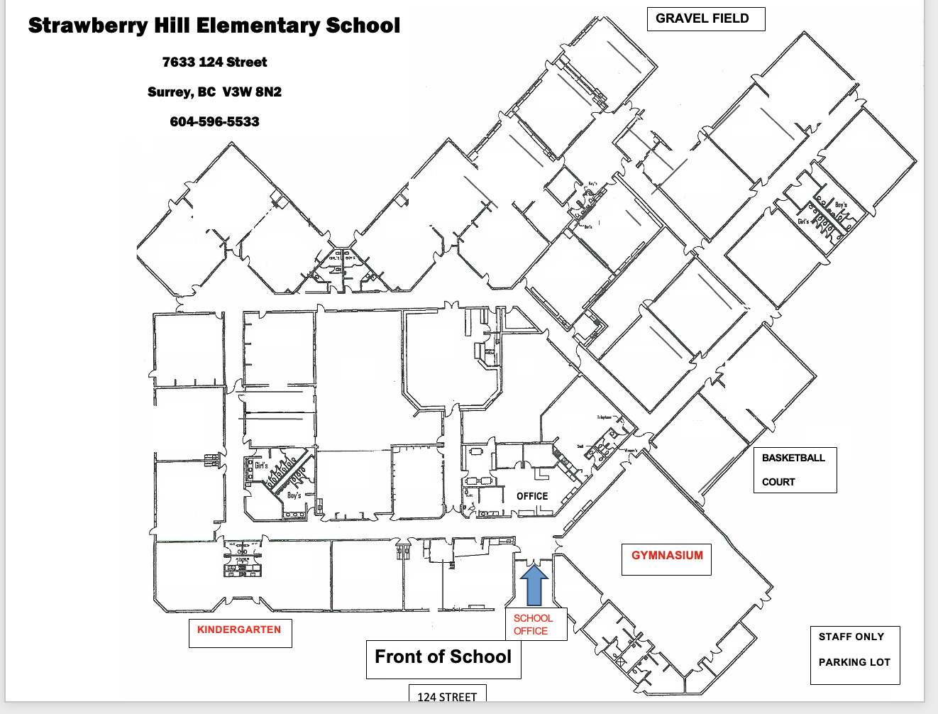

We look forward to seeing everyone on September 2nd ! The school is open August 25th- August 29th from 9 a.m. – 2 p.m. Please do not hesitate to drop by the school, call (604-596-5533) or email (strawberryhill@surreyschools.ca) if you have any questions.
See you soon,
Mrs. Deol - Principal Mrs. Gill - Vice Principal

