What You Need to Know About Potassium
This article was written and reviewed by dietitians from Dietitians of Canada. Last Update – March 21, 2019

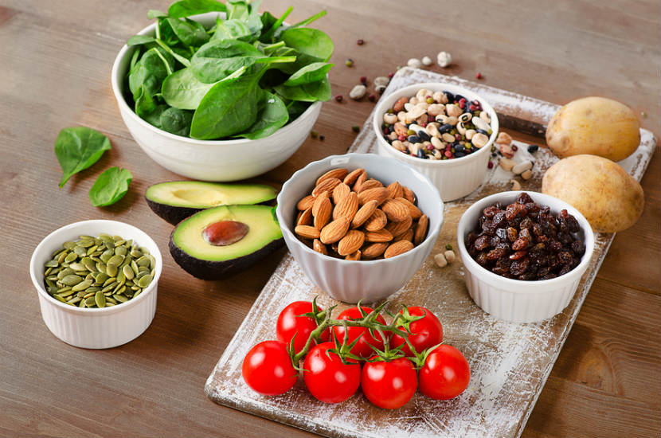
Potassium is an important mineral that your body needs and is classified as a “get more of” nutrient because of the many important roles that it plays in keeping us healthy. Potassium regulates the heartbeat, ensures proper function of the muscles and nerves, and is vital for synthesizing protein and metabolizing carbohydrates. Potassium is also necessary for the normal functioning of all cells. It also helps move nutrients into cells and waste products out of cells. A diet rich in potassium can also helps to offset some of sodium's harmful effects on blood pressure.

How much potassium do I need?
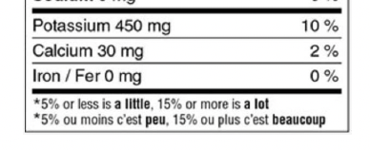
Most Canadians can get enough potassium as long as they are making healthy choices based on Canada’s Food Guide. The amount of potassium you need depends on your age and life stage. Health Canada recommends that individuals 14 years and older should consume 4700 mg of Potassium a day. Use the Nutrition Facts table to compare and choose foods to get 100% DV of this nutrient.
Which foods have potassium?

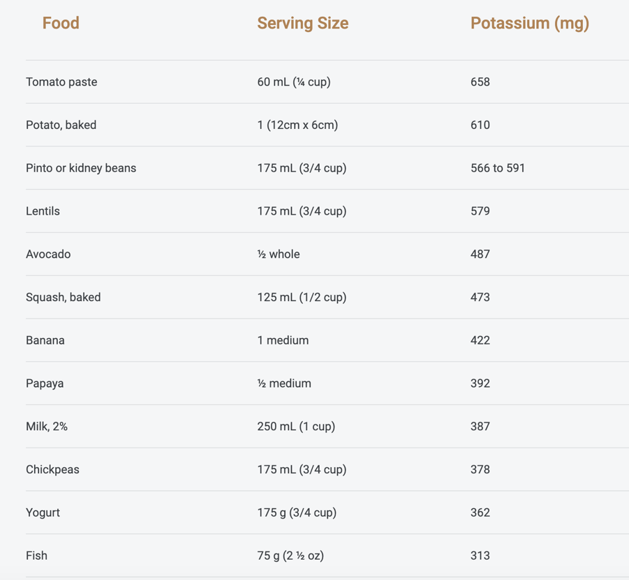
Vegetables and fruit are some of the best sources of potassium. Grains, dairy products, lentils, meat and fish also have potassium. It is important to make sure you are eating a variety of foods to help you get the amount you need. A potassium-rich diet keeps you healthy and may also help to reduce blood pressure and water retention, protect against strokes and help prevent against osteoporosis and kidney stones. Bananas are often recognized as a good source of potassium, but other fruits (such as apricots, prunes, and orange juice) and vegetables (such as squash and potatoes) also contain nutrient.

Do I need a potassium supplement?

No. Healthy individuals do not need a potassium supplement unless a doctor recommends it. It is best to get the potassium you need from a variety of foods.

