This question is one I’ve heard time and time and time again. I’ve heard it in multiple contexts, from taking on social justice initiatives to Aboriginal Curriculum Infusion.
This perceived frustration is one that I which to dispel through 4 lenses: Goals, Strategies, Content, and Process.
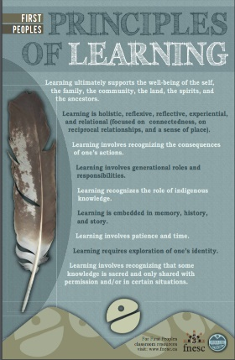
I feel these four lenses would allow significantly easier access points for individuals that might not be steeped in Indigenous Ways of Knowing, or are have teaching concentrations which may be a tad more inflexible towards infusion of what some would suggest more “humanities centered material”( something which I don’t ascribe to but have heard stated). These four lenses are meant to connect with the First People’s Principles of Learning and the way that we utilise these principles in our classroom. A note from Sue Spalding, a fellow social justice advocate and colleague, try taking one Principle, talk it over as a staff, and see how it can be applied.

And so, here goes nothing, scratch that, here goes everything.
G | oals – When you look at whatever you are teaching, what goals do you have for your students? Are there ways that the FPP’s could be utilized as goals in and of themselves ( similarly to the Bix Six of Historical Thinking for example)?
S | trategies – When we consider indigenous epistemology and pedagogy, can we utilize some of those strategies in our teaching. Rather than a top-down model, why not a decolonized understanding, where the voices of students are central, and where the traditions of elders, community and heritage are given more priority? Can a talking circle promote more dialogue and equality than desks lined up in columns?
C | ontent -I admit this is a difficult one, as based on the region, the nation, and the funding, resources might not be readily available. Nonetheless, inviting a speaker to share their lived experiences, that is content. Finding and exploring counter-narratives that put a new twist on our history, that is content. Student generated content such as the amazing group N’we Jinan, can provide such deep learning. Most Importantly, that as a social justice union we need to promote the funding, and development of First Nations resources, and capacity across the board ( from Federal to Municipal to within Nations). We should not accept the old line of “here’s new curriculum, but no money for resources”. What we need to realize is that content-building, builds up not just our libraries, but the strength of Nations to write their own stories, represent their own historical narratives, and stand strong in the hopeful reality of a true Nation to Nation relationship.
P | rocess Questions in regards to authenticity and appropriation are perhaps the two areas that cause the most consternation. If we address the very process of acquiring content, and the use of strategies and pedagogies, we do not need to fear Aboriginal infusion. Yes some background knowledge may be required, but in all honestly, that is what makes us the teaching professionals we are. Think for a second of sacred knowledge from other cultures, many people who are not part of the Islamic faith are aware that the drawing of Mohammed is not permitted. Many people who are not Christian understand that the cross should not be desecrated. There are many more examples that suggest sacred knowledge is all around us, and that with understanding, we understand the process which we must go about to use that knowledge. In following process therefore, ask an elder, do some research as to the content itself (totem poles, headdresses, drums, ceremony etc), always ask for permission when using all content, and always stay as far away as possible from overarching generalities, or cultural relativism that might take away from the knowledge in and of itself.  I hope these 4 frameworks of GOALS, STRATEGIES, CONTENT, PROCESS, allow some relief from the anxiety some teachers feel, and that in attempting only one of the 4 frames, and focusing on only one principle, realize that you are already infusing Aboriginal understandings, and knowledge. NO, you don’t need to be an expert, so very few of us are. At the same time, what a wonderful thing it is for a teacher to say “I am learning too” and to promote the idea that knowledge acquisition never truly ends.  The words of one of my students Calista Robinson and N’we Jinan’s song “Hide and Seek”  “Reconciliation is in every time we learn”

