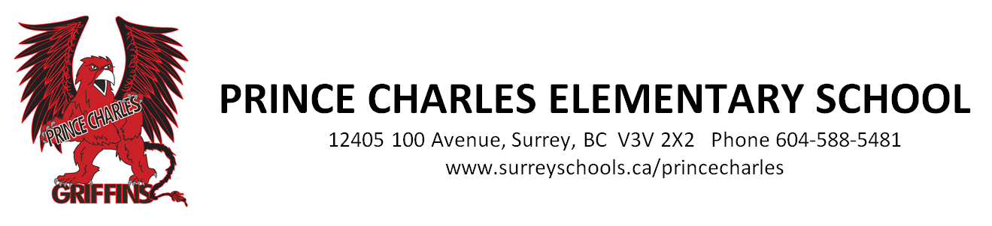

November 19, 2018

Dear Parents/Guardians,

Our students and staff have been working tirelessly on a musical that we are proud to present to you soon. On Wednesday December 5, we will have two showings of our musical, Holiday Pajama Party:

Afternoon performance (dress rehearsal) – 1:00pm at Prince Charles Elementary School
Evening performance – 6:30pm at Prince Charles Elementary School

Tickets for our afternoon dress rehearsal are free and can be picked up at the office. Please make sure to pick up your tickets ASAP as there will be limited seating at the afternoon performance.

Tickets for our evening performance can be purchased for $2.00 at our school office starting on Monday, November 19th. Please make sure to purchase your tickets early. A maximum of 4 tickets per family will be sold. There will be no tickets for sale at the door for the 6:30 pm performance.

Our costumes for this musical are very simple - pajamas! We ask that your child please wear their pajamas to school if possible on Wednesday, December 5th, and again to our evening performance. It will get warm in the gym with the stage lights and all of the people, so lighter weight fabric pajamas are recommended over a full flannel pajama set. Bathrobes or housecoats are not recommended as students will definitely be far too warm on stage in those.

Students should meet their teacher in their classroom no later than 6:00pm on December 5. Parents are asked to wait until after the final song to collect their students from their classrooms. Our final song of the evening features all of our students, and we will endeavor to have them back in their classrooms as soon as possible after the final number.

Parents and family members are welcome to make an audio or video recording of their child from their seat, and take as many pictures as they like. We do ask, however, that you do turn off the flash on your cameras while taking photos. A video recording of the full musical will be made available through Ms. Zorn in the week following the performance, and can be put onto a DVD or USB stick provided by you. . Please label your blank DVD or USB with your child’s name and division to guarantee they are returned to the correct student as soon as possible.

If you have any questions about Holiday Pajama Party, please feel free to email Ms. Zorn at zorn_s@surreyschools.ca at any time.

Thank you, and we look forward to seeing everywhere at the show!

Ms. Stacey Zorn, Music Teacher and Ms. Jen Gale, Grade 4 Teacher

