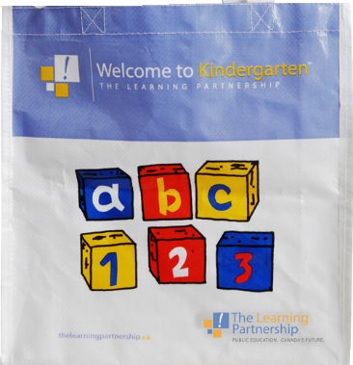
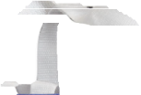
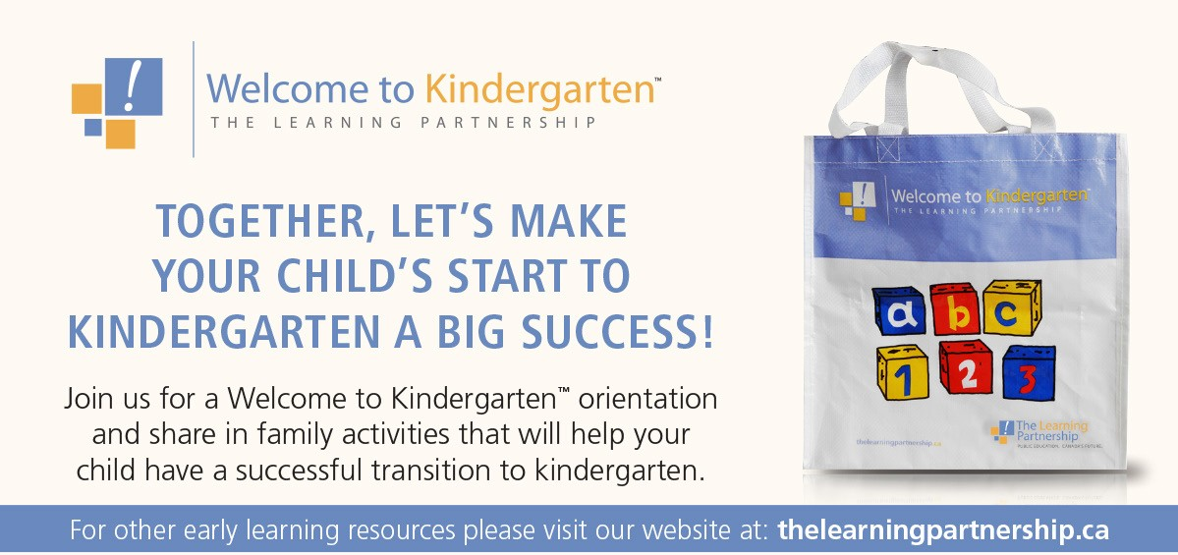

TOGETHER, LET’S MAKE YOUR CHILD’S START TO
KINDERGARTEN A BIG SUCCESS!

Join us for a Welcome to Kindergarten™ orientation and share in family activities that will help your child have a successful transition to kindergarten.

For other early learning resources please visit our website at: thelearningpartnership.ca

You and your child are invited to our school’s Welcome to Kindergarten™ orientation on:

Date: Wednesday, April 18, 2018

Time: 1:00 – 2:00

Place: Ellendale Elementary

Contact info: Call the school for more information

School RSVP: # 604-584-4754 or email: ellendale@surreyschools.ca

____

School personnel and community partners will share fun activities that you can do at home with your child.

You will receive a Welcome to Kindergarten™ bag with magnetic letters and numbers, books, crayons, scissors, glue, playdough and more!

