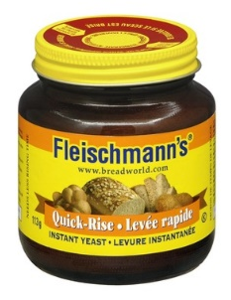
YEASTBREADS
SAVE A TREE – DO NOT WRITE ON THIS INORMATION PAGE – RETURN TO TEACHER
Flavour, aroma and texture are the qualities that account for the popularity of yeast bread and rolls. Yeast breads differ from quick breads in that they are leavened by yeast, a living organism, rather than baking soda and baking powder and are often lower in fat and sugar. When mixed with water and sugar, the yeast ferments to produce carbon dioxide, filling the bread dough with tiny air bubbles. Water also combines with the gluten (protein) in the flour to form the elastic structure of the dough that traps the air bubbles and makes the bread rise.

In a hurry… reach for Quick Rise yeast. It works twice as fast as Traditional. yeast.

TYPES OF DRY YEAST:

ACTIVE DRY YEAST- has a larger granule and needs to be dissolved in water before using.

INSTANT YEAST- has a finer texture and can be mixed right into dry ingredients.

HOW DO I STORE YEAST?

Newly purchased yeast may be stored in a cool location, refrigerated, or frozen for up to two years. Once the yeast has been opened, it should be kept in the refrigerator and used within four months or frozen for up to six months. After the recommended storage times or past the expiry date, yeast may not grow as rapidly as expected or at all.

IS YEAST ALIVE? Yes! And to grow and create carbon dioxide it needs 3 things:

- Food such as starch and sugar to feed the yeast so that it can produce carbon dioxide. The right amount of sugar is very important in yeast breads. During rising, yeast feeds off the sugar as long as there is some available. Changing the amount of sugar needed in a recipe changes how long the yeast has to feed and can result in too light a product.

- Moisture. Water works best at the beginning but milk can be used in later steps. Just be sure to scald the milk before using it because it contains bacteria that need to be destroyed.
Low temperatures (under 10˚C), cause the yeast to grow very slowly.
Optimal temperatures (25˚C-30˚C), create the perfect environment for yeast growth and it multiplies rapidly.
High temperatures (above 60 ˚C, like when cooking in the oven), kill yeast and stop the production of CO₂.

- Warmth. Yeast is very sensitive to temperature so it is important to keep it in the correct temperature range.

WHAT HAPPENS WHEN DOUGH IS RISING?

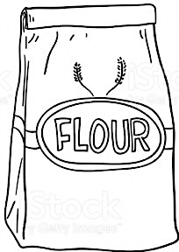
Fermentation is the important process where yeast feeds and convert sugar into alcohol and carbon dioxide gas. CO₂ gas is trapped within the framework of gluten strands which forces them to stretch and the bread to expand. Fermentation is complete when the dough has doubled in size and will hold a finger impression.

BAKING TIPS:
- With bread making, exact flour measurements are impossible. Dough is affected by heat, humidity, sugar, altitude and possibly the personality and the mood of the baker. Follow the recipe as a guide but let the dough tell you what it needs. If it sticks to your hands then add a little more flour, if the dough is heavy and not picking up the extra flour on the counter then move it to a clean work area to finish kneading.

- Salt should not be omitted because it controls the action of the yeast. Besides having a very bland flavour, breads made without salt tend to over-rise and will have a different texture than breads with salt.
Kneading is easy!

Grasp dough and bring towards you, flip the dough then form a fist and push dough away from you with your knuckles, repeat the process until the dough is smooth and elastic

- Kneading develops the gluten, forming a mesh that traps the gas produced by the yeast. Don’t rush this process! A dough with not enough gluten strands developed has poor volume and a coarse crumb because it was not able to stretch and hold the gases.

- To test if dough is sufficiently kneaded, poke the dough with your fingers; it should spring back. Properly kneaded dough will feel smooth and elastic.

- Don’t forget the oil. Oiling the surface of the dough before letting it rise prevents the surface from drying out and forming a crust.

- To slow the rising process, the dough may be placed in the refrigerator or cooler liquids may be used.

- What to enhance the look of your final product? Try an egg wash to give the final product a golden brown color that is slightly shiny.

- After baking, remove the bread from its pan, set on a rack and let cool slowly in a draft-free place. When cooled, place in a plastic bag or plastic wrap and store at room temperature. It will last from two to seven days, depending on the bread.

